

Business Searching Interface
User Guide

Table of Contents
EBSCO's Business Searching Interface 4
Basic Search 4
Advanced Search with Guided-Style Fields 6
Advanced Search with Pre-Selected Fields 8
Search History 11
The Search History Screen 12
Search Tools 13
Boolean Operators (And, Or, Not) 13
Using Stop Words 14
Using Quotation Marks 14
Using Punctuation 14
Wildcard (?) and Truncation (*) Symbols 15
Field Codes 15
Proximity Searches 15
Limiters 16
Expanders 17
Guided Search Fields 17
Browsing by Subject 18
Term Begins With 18
Term Contains 18
Relevancy Ranked 19
Using Explode and Major Concept 19
Searching for People and Places 20
Browsing an Index 21
Cited Reference Searching 22
Browsing Cited References 22
Searching for Cited References 24
Searching by Publication 26
Marking Items for Search 27
Setting Up a Journal Alert 29
Saving Searches and Alerts 31
Saving Searches 31
Saving a Search as an Alert 33
Setting Up a Personal Account 35
Setting Up a Charge Back Account 36
Viewing Search Results 37
Viewing the Result List 37
Viewing the Full Record 39
Available Formats 39
Citation View 39
HTML Full Text View 40
PDF View 40
Linked Full Text View 41
The Folder 41
Linking to Information 42
SmartLinks 42
Persistent Links 42
CustomLinks 42
Using Translation Features 43
How Automatic Translation Software Works 43
Setting Preferences 44
Saving Results to the Folder 45
Your Personal Folder 45
Printing/Emailing/Saving 46
Printing Your Results 46
Saving Your Results to a File 48
Emailing Your Results 51
Custom Fields for Print/Email/Save 53
Creating a Bibliography 54
What is a Bibliographic Manager? 54
Saving a Bibliography File 55
Emailing a Bibliography File 56

EBSCO's Business Searching Interface
The Business Searching Interface (BSI) provides an easy way to both browse and search for country economic data, company profiles, industry information and market research, and then use the results as limiters in a keyword search, if desired.

Basic Search
On the Business Searching Interface, Basic Search provides both the ability to keyword search and a "lookup" feature that lets you search within the Indexes and Authority Files. You can also go directly to screens that let you browse Company Profiles, Industry Reports, Country Reports and Market Research Reports.

To conduct a Basic Keyword Search:
- From the Basic Search Screen, enter search terms, select the Keyword radio button and click Search. 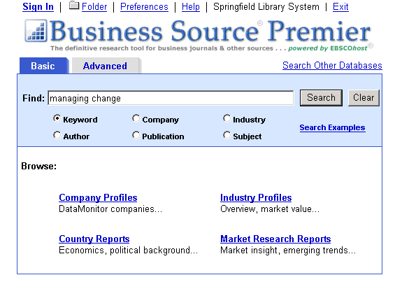
- A Keyword search is run against the main database and a Result List is displayed. The search terms are retained in the Find field above the Result List.
  - To return to Basic Search with your search terms retained, click Refine Search.
  - To return to Basic Search with your search terms cleared, click the BSP or BSC logo.
  - To carry your search terms and expanders over to Advanced Search, click Advanced Search.

To search an Index or Authority File:
- From the Basic Search Screen, enter search terms, select a radio button other than Keyword and click Search.
- The Index or Authority File you selected is displayed at the closest match to your search terms. If no terms were entered, the Index or Authority File displays at the beginning of the list. 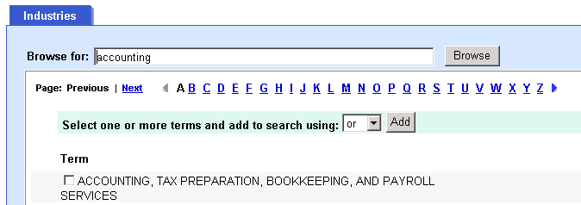
- Mark terms, add them to the Find field, and click Search. A Result List is displayed. Your search terms are retained in the Find field above the Result List.

To access Browse Screens:
- From the Basic Search Screen, click on any of the links on the Browse area of the screen. (Company Profiles, Industry Reports, Company Reports or Market Research Reports.)
- The corresponding Browse list of available profiles or reports is displayed. You can mark items, add them to the Find field, and click Search. A Result List displayed. 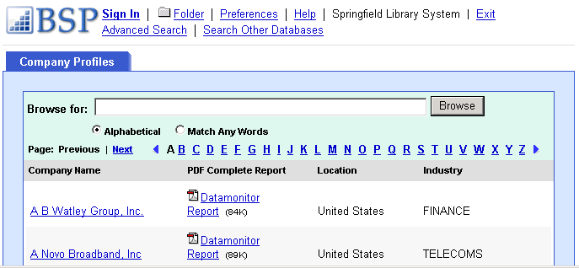

Advanced Search with Guided-Style Fields
If you click Advanced Search from a Basic Search Result List, your search terms are placed in the first search field on the Guided-Style version of Advanced Search. If the library administrator set any "hidden" expanders, they are also carried to Advanced Search.

To create an Advanced Search:
    - From Advanced Search, enter your search terms in the guided-style Find fields. You can enter text on all three lines, select Field Codes from the drop-down lists, select Boolean operators (and, or, not) to connect search terms, and mark any limiters that you want. 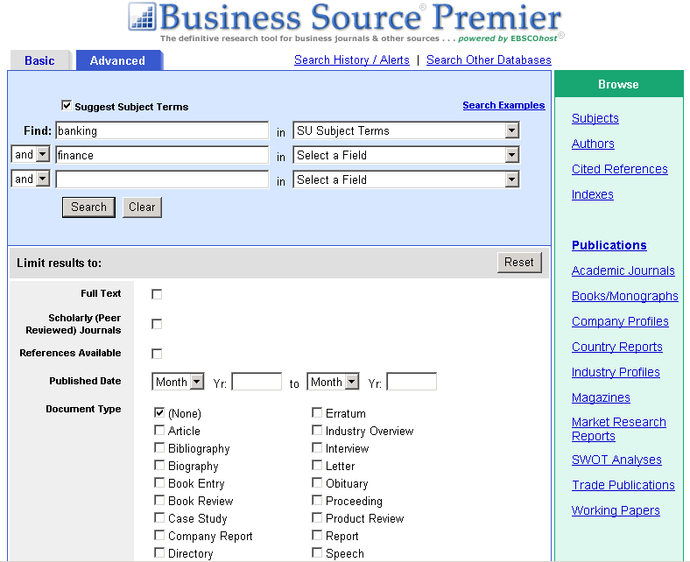
    - If a More Options link appears, you can click it to view all limiters and expanders that are available. You can add any of these limiters/expanders to your search.
    - Click Search. A Result List is displayed.
    - To refine your search from the Result List, click the Refine Search link. You will be returned to Advanced Search with search terms, limiters and expanders retained in the appropriate fields.

The Boolean Operators (And, Or, Not)
- And - combines search terms so that each search result contains all of the terms. For example, travel AND Europe finds articles that contain both travel AND Europe.
- Or - combines search terms so that each search result contains at least one of the terms. For example, college OR university finds results that contain either college OR university.
- Not - excludes terms so that each search result does not contain any of the terms that follow it. For example, television NOT cable finds results that contain television but NOT cable.
Note: If "Suggest Subject terms" is marked, but Field Codes are used, “Suggest” is ignored and a keyword search is run. If only limiters are selected, “Suggest” is ignored and a keyword search on the limiters selected is run.

Advanced Search with Pre-Selected Fields
The Company, Industry, Author and Publication fields are “pre-selected” search fields that can be used separately or in combination with the Keyword Find field on Advanced Search. The fields are connected via and.

To create an Advanced Search using Pre-selected Fields:
- From the Advanced Search Screen, enter terms in the Find field and combine with the pre-selected fields, or use them separately. 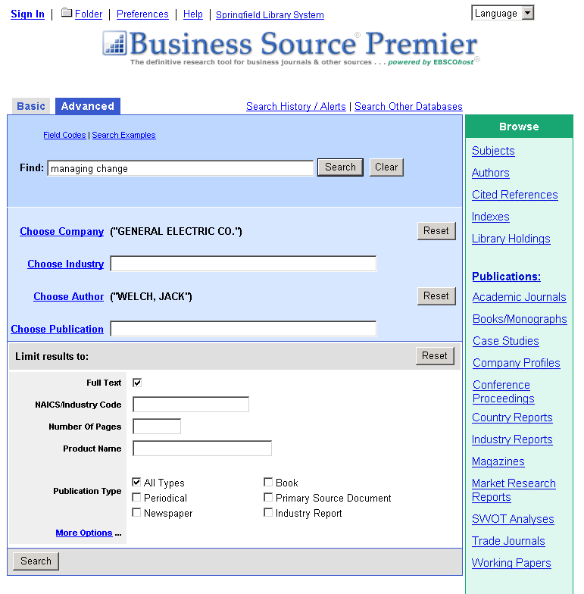
- Click one of the links next to the pre-selected fields, e.g., Choose Company, etc.
- A pop-up window displays the appropriate list (company, industry, author, publication). Select the terms from the list and click the Add to Search button. The terms are added to the pre-selected Find field. To clear the entry field, click Reset.
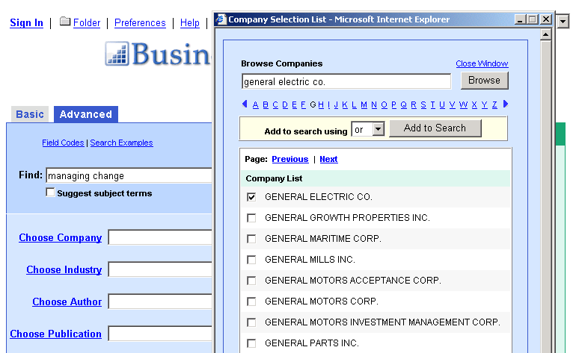
(If you enter terms in the pre-selected field before clicking on the lookup list link, you will be positioned to the nearest term in the list that matches your entry. Once you add terms from the list to the search, your previous entry in the pre-selected field is replaced by the newly added terms.)
- Select any limiters that you want to apply. (If a More Options link appears, you can click it to view all limiters that are available.)
- Click Search. A Result List is displayed. 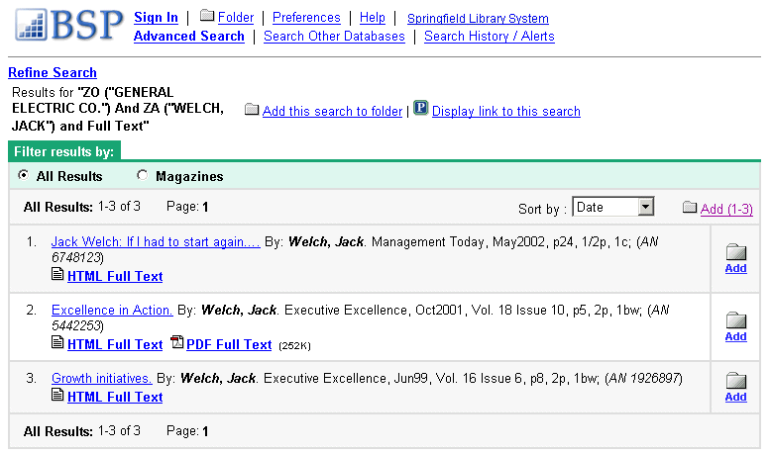
- To refine your search from the Result List, click the Refine Search link. You will be returned to Advanced Search with search terms, limiters and expanders retained in the appropriate fields.
Notes:
- Upon revising or re-running a line of search history for a search created with pre-selected fields back into the Advanced Pre-selected style screen, the search string, limiters and expanders are displayed in the appropriate boxes. (When the search terms are “posted,” that state is retained when the user revises or re-runs the search.)
- If you refine a search after following a persistent link to a search with pre-selected fields (and the link provides the user with full access to the Business Searching Interface), the search string is displayed in the top Find field, and limiters are displayed in the appropriate boxes on the Advanced Search Screen with pre-selected fields.
- If "Suggest Subject terms" is marked, but Field Codes are used, “Suggest” is ignored and a keyword search is run. If only limiters are selected, “Suggest” is ignored and a keyword search on the limiters selected is run.

Search History

To use search history:
- On the Search History Screen, up to five of your most recent searches are displayed. You can click Show More (or Show Less) to control how many searches performed in the current session are displayed. 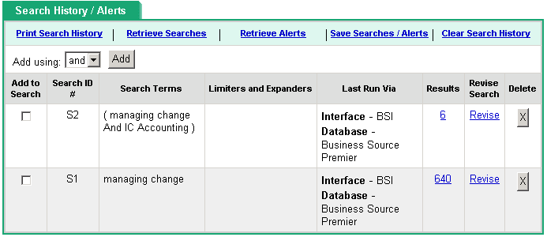
- You can do any of the following:
  - Mark the lines of search you want to use and click the Add button. You will be returned to the search screen with the lines of search added to the Find field.
  - Click Search. A Result List is displayed.
  - Click a Rerun link or a linked number of results. The search is automatically run and a Result List is displayed.
  - Click a Revise link. You will be returned to the search screen with the terms added to the Find field and any limiters/expanders marked. Click Search. A Result List is displayed.
- To clear your search history, either click Clear Search History, or end your session.
- The search history available to you includes only the searches from the current EBSCO session using the Advanced Search Screen. Unless you create a saved search, when your session ends, search history is cleared.
- If you change databases, your search history is saved (the query only, not the result counts).
- If the limiters and expanders you applied in the original databases are not available when you change databases or interfaces, your searches may be affected.
- If search history is opened in the new database or interface, "Rerun" appears in the Results column. This indicates that the counts are not known because the search has not been run on your current database or interface. When you view the results (by clicking on the "Rerun" link), a new search is launched and its results counts are added to the search history.
There may be situations where you rerun a search and obtain results that are different than expected.
- If you run a search against a different database or interface, the limiters and expanders you originally selected may not appear in the new database.
- If you run a search against the same database or interface, but the database has changed, the limiters and expanders you originally selected may no longer be available in that database.

The Search History Screen
Add to Search - To combine lines of history, mark the check box to the left of the lines and select a Boolean operator (and, or, not) from the drop-down list, and click Add. The lines of history will be placed in the Find field.
Search ID # - The number assigned to your search. You can also select a search from the list by entering S and the search number (S1, S2, etc.).
Search Terms - The terms you entered in the Find field, including any field codes or Boolean operators.
Limiters/Expanders - The limiters and/or expanders used in your search are shown.
Last Run Via - For each line of search history, the interface, search screen and database on which the search was last run.
Results - Either the exact number of search results, or "Rerun" appears as a hyperlink.
Revise Search - Indicates that the lines of search can be edited. When you click Revise, the search terms are displayed in the Find field. You can then edit the search manually, entering field codes or changing limiters and expanders on the Refine Search sub-tab. A new line of history is created.
Delete - Indicates that individual lines of search history can be deleted. If you delete a line earlier within search history, any dependent lines are deleted, and the remaining lines of history are renumbered. A message appears when you delete lines of search history.

Search Tools

Boolean Operators (And, Or, Not)
Boolean logic defines logical relationships between terms in a search. The Boolean search operators are and, or and not. You can use these operators to create a very broad or very narrow search.
- And combines search terms so that each search result contains all of the terms. For example, travel and Europe finds articles that contain both travel and Europe.
- Or combines search terms so that each search result contains at least one of the terms. For example, college or university finds results that contain either college or university.
- Not excludes terms so that each search result does not contain any of the terms that follow it. For example, television not cable finds results that contain television but not cable.
The following table illustrates the operation of Boolean terms:

And | Or | Not
Each result contains all search terms. | Each result contains at least one search term. | Results do not contain the specified terms.
The search heart and lung finds items that contain both heart and lung. | The search heart or lung finds items that contain either heart or items that contain lung. | The search heart not lung finds items that contain heart but do not contain lung.

Using Stop Words
Stop words are commonly used words such as articles, pronouns and prepositions. Stop words are not added to the search dictionary, since their relevance is minimal, but they are counted as words for proximity (the distance between words). Ignoring stop words allows the program to retrieve a more precise Result List, especially for a relevancy ranked search.
The search engine ignores stop words (such as the, for, of and after), finding any single word in its place. For example, if you entered company of America, the search engine would find company of America, company in America, or company for America. It would not find company of the America, because the search engine retains a word distance.
If you enter two stop words, the search engine will find any two words in the place of the stop words. For example, if you searched for company of the America, the search engine finds any two words in the place of the stop words.
EBSCO has two primary lists of stop words, separate for Boolean and Natural Language searching. Additionally, several databases have their own list of stop words. All of these lists were created based upon The Library of Congress' suggestions on stop words, as well as our own statistical analysis.

Using Quotation Marks
Typically, when a phrase is enclosed by double quotations marks, the exact phrase is searched. This is not true of phrases containing stop words. A stop word will never be searched for in an EBSCO database, even if it is enclosed in double quotation marks. A search query with stop words only (i.e. no other terms) yields no results.

Using Punctuation
If you enter phrases with punctuation, the search engine searches for the term both with and without the punctuation. For example, if you enter television: talk show, the search engine finds results with television talk-show, television talk show, and if synonyms have been activated, TV talk show.
If you enter hyphenated words in a search, the search engine automatically searches for the word in both hyphenated and non-hyphenated forms. For example, entering coca-cola will find both Coca Cola and Coca-Cola.

Wildcard (?) and Truncation (*) Symbols
Use the wildcard and truncation symbols to create searches where there are unknown characters, multiple spellings or various endings. Neither the wildcard nor the truncation symbol can be used as the first character in a search term.
- The wildcard is represented by a question mark (?). To use the wildcard, enter your search terms and replace each unknown character with a ?. The search engine finds all citations of that word with the ? replaced by a letter.
For example, type ne?t to find all citations containing neat, nest or next. The search engine does not find net because the wildcard replaces a single character.
- Truncation is represented by an asterisk (*). To use truncation, enter the root of a search term and replace the ending with an *. The search engine finds all forms of that word.
For example, type comput* to find the words computer or computing.

Field Codes
You can use field codes to create a search using indexed fields referenced in either the citation or full display (or full text, if available). EBSCO uses two-character abbreviations for field codes such as SU-Subject, AU-Author or TI- Article_Title.
Field codes are database specific. For more information on which searchable fields are available for a database, on the Choose Databases Screen, click the More Information link for the database.

To create a search using a field code:
- At the Search Screen, type one of the two-letter codes before your search terms in the text entry field. For example, to search for articles that include the subject sports injuries and the term hockey, type: SU Sports Injuries and Hockey.
- Click Search. The Result List appears.

Proximity Searches
You can use a proximity search to search for two or more words that occur within a specified number of words (or fewer) of each other in the databases. Proximity searching is used with a keyword or Boolean search.
The proximity operators are composed of a letter (N or W) and a number (to specify the number of words). The proximity operator is placed between the words that are to be searched, as follows:
- Near Operator (N) - N5 finds the words if they are within five words of one another regardless of the order in which they appear.
For example, type tax N5 reform to find results that would match tax reform as well as reform of income tax.
- Within Operator (W) - In the following example, W8 finds the words if they are within eight words of one another and in the order in which you entered them.
For example, type tax W8 reform to find results that would match tax reform but would not match reform of income tax.

Limiters
Limiters let you narrow the focus of your search so that the information retrieved from the databases you search is limited according to the values you select. You can use more than one limiter if more than one is available.
Common limiters that can appear on Advanced Search include:
- Full Text – Click to limit results to articles with full text.
- Cover Story – Click to limit results to articles that were featured as cover stories.
- Local Titles – Click to limit results to articles available at your library.
- Journal/Magazine - Enter a journal/magazine name in this field to limit results to articles only from that title.
- Peer Reviewed - Limits search results to articles from peer-reviewed journals. Peer-reviewed journals are publications that include only those articles that have been reviewed and/or qualified by a selected panel of acknowledged experts in the field of study covered by the journal.
- Date Published - Use this option to search for articles within a specified date range. Create a range by using the drop-down lists to specify the months of the range and enter the last two digits of the year in the entry fields to specify the years of the range.
- Number of Pages - Enter a number in this field to limit results to a specific number of pages in length. Place the < (less than) or > (greater than) symbol before the number to search for articles with a specific page length range. For example: to search for articles that are greater than three pages in length, enter >3 in this field. You can also use a dash to enter a range of pages. For example, to find articles between five and ten pages long, enter 5 - 10.
Limiters do limit one another. If you select both Full Text and Cover Story limiters, the results that are retrieved include only Full Text items that are Cover Story items. The exception to this rule is the use of Full Text and Local Titles limiters. In this situation, use of these limiters produces a list of results that has Full Text or is part of a local collection. Limiters may vary by interface, database and search screen.

To create a search using a limiter:
- In the Find field, enter your search terms.
- Select the limiter you want to use from the Limit Your Results section of the Search Screen.
- Click Search. The Result List appears.

Expanders
Expanders let you broaden the scope of your search. They do this by widening your search to include words related to your keywords or including the actual text of the full text results in your search.
Common expanders that may appear on Advanced Search include:
- Also search within full text articles - Select this option to search for your keywords within the full text of articles, as well as abstract and citation information. This applies only to words not qualified by a field code.
- Include all search terms by default - Select this option to search for all terms you entered, in any order within the text. Your terms are automatically "anded" together. If you surround terms with quotation marks, the phrase within the quotation marks is treated as one term.
- Also Search for related words - Select this option to expand results to include the synonyms and plurals of your terms.

To create a search using an expander:
- On Advanced Search, enter your search terms in the Find field.
- Select the expander you want to use from the Expand results to area of the Search Screen.
- Click Search. The Result List appears.

Guided Search Fields
The library administrator can choose to show guided search fields on the Advanced Search Screen.
If the guided search fields are displayed, you can enter text on all three lines. If you do not enter terms on line one, the operator to the left of line two is ignored. (You can begin a search string on line two.)
After you click Search, the input from all three lines is joined together on the first line. And takes precedence over or when the system groups items together. Parentheses are assigned based on this logic. To force grouping, you can enter the parentheses or place "grouped" expressions together in a single input field.

Browsing by Subject

To browse by Subject:
  - From the Advanced Search Screen, click the Subjects link. The Subjects Browse Screen is displayed. 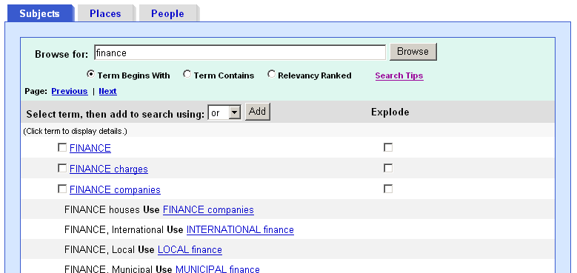
  - Enter your search terms in the Browse for entry field, and then select from: Term Begins With, Term Contains, or Relevancy Ranked radio buttons and click Browse.
  - A list of headings is displayed. In some databases, you can hover over the Scope link and view the entire Scope Note. Clicking on the Scope link positions you directly at the Scope Note area of the detail screen.
  - As you select headings, mark explode and/or major concept, and then add to your search using and, or, or not, your search is being built in the Find field.
  - To display a list of results that match your search terms, click Search.

Term Begins With
If you browse the Subject list and enter “finance” in the Browse for field and select Term Begins With, the list displays the terms in alphabetical order:
FINANCE
FINANCE charges
FINANCE companies
FINANCE houses Use FINANCE companies
FINANCE, International Use INTERNATIONAL finance
FINANCE, Local Use LOCAL finance

Term Contains
If you browse the Subject list and enter “finance” in the Browse for field and select Term Contains, the term searched for appears first followed by a list of terms displayed in alphabetical order:
FINANCE
ACCOUNTING -- Effect of inflation on
AGENCIES, Rating (Finance) Use RATING agencies (Finance)
ANTI-inflationary policies
BANK investment contracts
BANKS & banking, Foreign

Relevancy Ranked
If you browse the Subject list and enter “finance” in the Browse for field and selected Relevancy Ranked, the exact match for the term appears first followed by a list of terms displayed in order of relevance.
FINANCE
LOCAL finance
CORPORATIONS -- Finance
HOUSING -- Finance
MUNICIPAL finance
OPTIONS (Finance)

Using Explode and Major Concept

Explode
When you Explode a term, you create a search query that “explodes” the subject heading. The headings are exploded to retrieve all references indexed to that term as well as all references indexed to any narrower terms.

Major Concept
When you select Major Concept for a term, you create a search query that finds only records for which the subject heading is a major point of the article. Searches are limited with specific qualifiers (subheadings) to improve the precision of the search, and limited to major subject headings indicate the main concept of an article.

Combining Explode and Major Concept
If you select Explode and Major Concept, you retrieve all references indexed to your term (and its narrower terms) and all articles for which the subject heading is a major point of the article.

Searching for People and Places
In certain databases, People and Places appear as additional sub-tabs when you view the Thesaurus or Subject Terms list.

To browse for People or Places:
- Click the People or Places sub-tab. 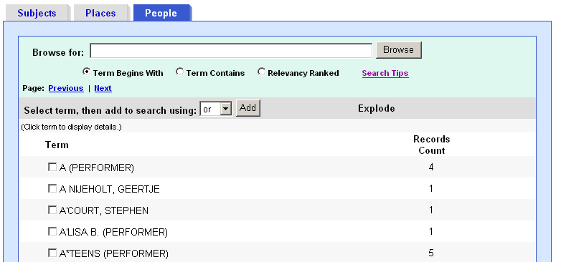
- Enter search terms in the Browse For field and click Browse. A list of indexed terms is displayed. (You could also page through the terms using the Next | Previous links and mark the terms you want.)
- You can mark terms and click Add. The terms are added to the Find field.
- Click Search. A Result List is displayed.

Browsing an Index

To browse Indexes from Advanced Search:
- From the Advanced Search Screen, click the Indexes link. The Indexes Browse Screen is displayed. 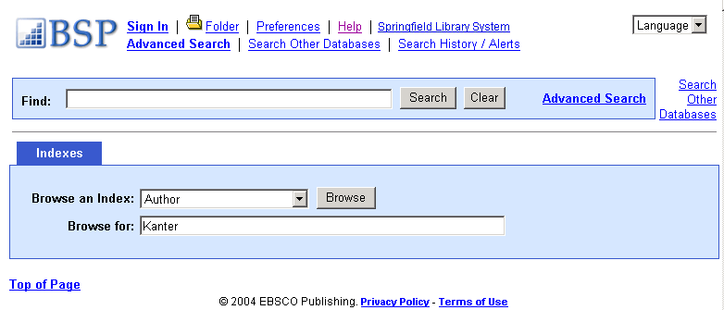
- From the Browse an Index drop-down list, select a field. (For example, Author or Subject—the fields vary by database. You can enter a term in the Browse for text entry field or leave it empty.)
- Click Browse. A list of index terms is displayed. 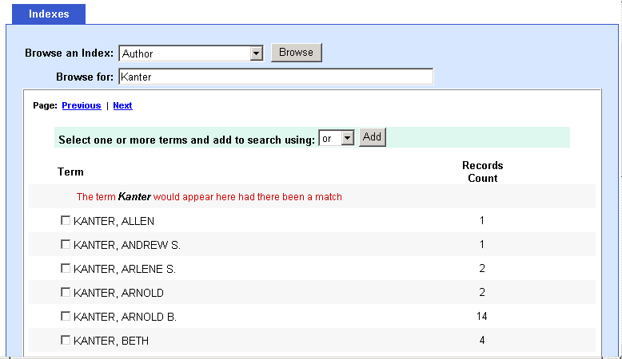
- Build a search query by marking the terms and selecting a Boolean operator (and, or, not). Click Search. You are returned to the Keyword Search screen. A Result List is displayed.

Cited Reference Searching

Browsing Cited References
Some databases provide the ability to "browse cited references." When you run a Basic or Advanced Keyword Search, any "Cited References" or "Times Cited in this Database" links that are available are presented with your search results. 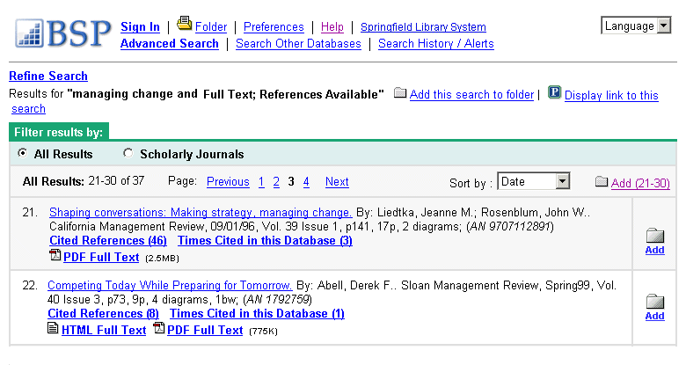
Cited References - If you click the Cited References hyperlink on a result, the Cited References sub-tab presents a list of records cited in your original article.
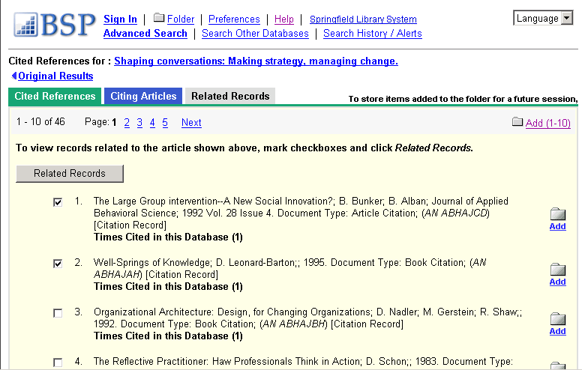
Related Records - If you select one or more cited references and click the Related Records button, the Related Records sub-tab presents a list of records related to your original article. These records are sorted by relevance, based on the greatest number of shared references.
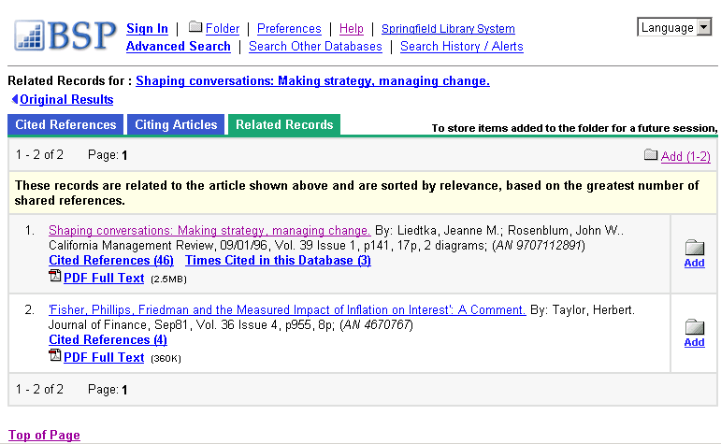
Times Cited in this Database - If you click the Times Cited in this Database hyperlink on a result, the Citing Articles sub-tab presents a list of records that cite your original article.
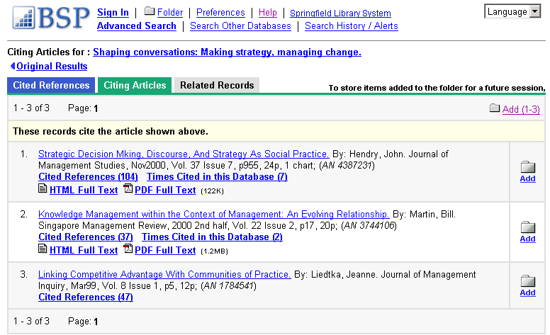
Cited References and Times Cited within this database hyperlinks are also displayed on the article detail page. Records with Cited References and Times Cited within this Database links can be saved to the folder. However, linking to Cited References or Citing Articles lists is not available from the folder.

Searching for Cited References
If a database supports “cited reference” searching as well as "cited reference” browsing, a Cited References Search Screen is also available.
Enter search terms in the author, title, source, year or all fields. The results of a cited reference search are displayed below the Cited References sub-tab. The Search fields remain available so you can edit your search terms or run a new search.
Cited References - From the Cited References Search Screen, the Cited References sub-tab presents a list of citation records for the search terms you entered.
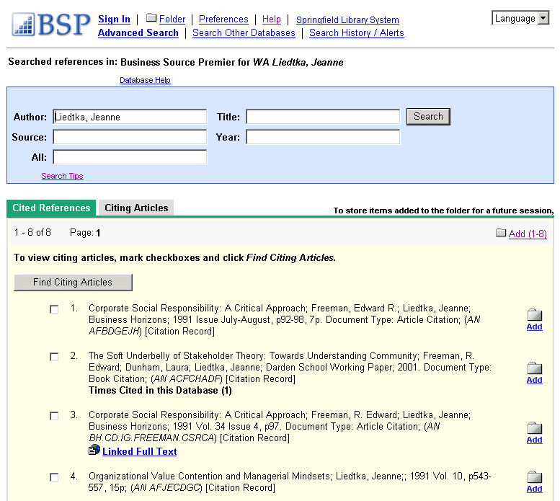
Citing Articles - From the Cited References sub-tab, you can mark check boxes, click Find Citing Articles, and retrieve a list of Citing Articles.
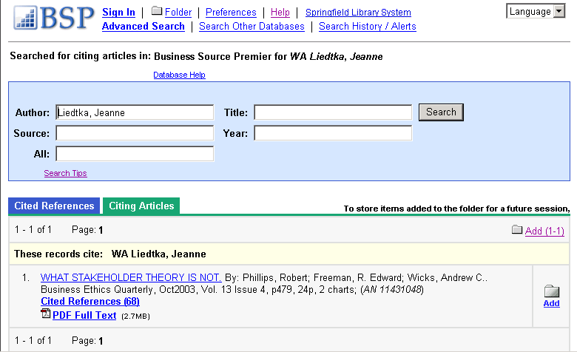
Note: Support for cited reference searching varies by database.

Searching by Publication
The Publication Authority File lists the information contained in a database according to journal or magazine name.

To browse a Publication Authority File:
- From Advanced Search, click the Publication link or any of the source-type links (Academic Journals, Magazines, etc.). The Publication Authority File (or section of the file--e.g., Newspapers) appears, with the beginning of the list displayed.
- From the Publications tab, enter your search terms in the Browse for field. You can enter all or part of a publication name. (For example, you could enter Time.) To narrow by source type (Industry Reports, SWOT Analyses, etc.), select from the Select Type drop-down list.
- Select a search type. Click one:
- Alphabetical - Finds journals beginning with the letters you entered. Results are displayed in alphabetical order.
- By Title, Subject & Description - Finds publications that carry that term in the Subject, Description or Title fields of the Publication Details.
- Depending on the type of publication you are searching for, additional selections may be displayed. When searching within Country or Industry Reports, you may also be able to narrow by Country, Region, Industry, or All Reports.
- Click Browse to view your terms as they appear in the Publication Authority File. A Result List is displayed.
- Browse the list by using the scroll bar or the arrow keys to move up or down the current page, or by using the up or down arrows at the top and bottom of the page.
For a description of the journal or publication, click the hyperlinked Publication Name. The information found in the Publication Details may include: the title, ISSN, publisher information (name, address, publisher URL), title history, bibliographic record and full text coverage, publication type, the subject and/or a description of the journal, and whether the journal is peer reviewed.
Hyperlinks to all issues are displayed in a column on the right side of the screen. If the journal displays a title history, you can switch between All Issues in the history or Current Title Only (the issues for the current title being displayed).

Marking Items for Search
You can use the Mark Items for Search feature to search several publications at the same time, or to combine publication names with other search terms.

To search for several publications at the same time:
- With the Publication Result List displayed, mark the check boxes to the left of the publications you want to search. Click Add. The publications you selected are placed in the Find field on the Search Screen. (They are combined with "or.")
- To search within those publications, click Search. To revise your search, you can add more terms in the Find field and click Search.
For example, enter science in the Browse for field and click Browse. You could then mark the publications Science and Society and Science as Culture, and click Add. Your selections would be posted in the Find field as:
JN "Science & Society" OR JN "Science as Culture"
You could click Search, and obtain results from both publications. You could also edit your search in the Find field, adding "and humanity" to your search. This would provide a different set of search results.

To search within a publication:
- From a journal's Publication Detail Screen, click the Search within this publication link. 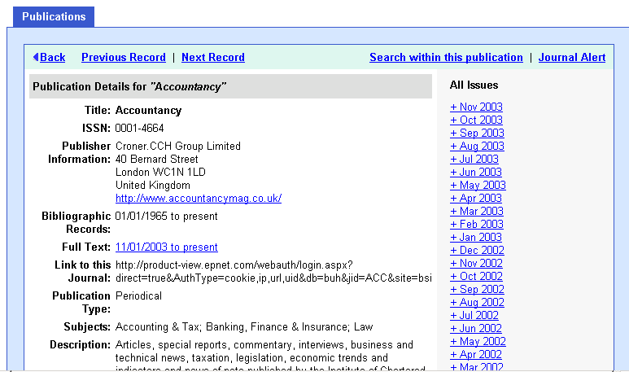
- The Search screen appears with the JN tag and the journal name entered in the Find field. Add any additional search terms and/or limiters and click Search.
- A Result List is displayed.

Setting Up a Journal Alert

To set up a journal alert:
- From the title's Publication Details Screen, click the Journal Alert link.
(If you have not already logged into your personal account, you will be prompted to log in. Enter your user name and password; or click Cancel to return to the Publication Overview Screen.)
- The Journal Alert Screen appears. The Journal Alert name, Date Created, Database, and Interface name are automatically filled in. 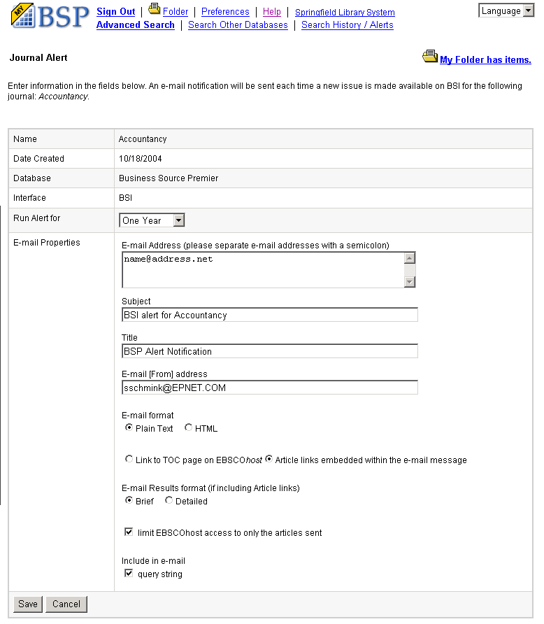
- In the Run Alert for field, select how long the journal alert should run:
  - One month
  - Two months
  - Six months
  - One year (the default)
- In the Email Properties section, to be notified by email when a new issue is available, enter your Email address. If you are entering multiple email addresses, place a semicolon between each email address.
- In the Subject field, enter a brief explanation that will appear in the subject line of the Journal Alert email.
- Title - you can optionally enter a title for the email. The default value for the title field is: BSP/BSC Alert Notification.
- Email [From] address - defaults to EPAlerts@epnet.com. You can enter a different "From" email address if desired.
- Select the Email format to use: Plain Text or HTML.
- Select whether you want the email to include: Link to TOC page on BSI or Article links embedded within the email message.
- Select the Email Results format to use: Brief or Detailed.
- To limit access to only the articles sent (rather than the entire site), mark the checkbox to the left of this field.
- To have your search string included in the email, click Include query string in email.
- When you have finished making changes, click Save. You will be returned to the Publication Details Screen. A message is displayed that indicates a journal alert has been set for the publication.

Saving Searches and Alerts

Saving Searches
If enabled by your library administrator, you can set up a personal account for use within the Business Searching Interface. (If you've set one up in EBSCOhost, you can use that same account.) You can save searches, retrieve and reuse them, and print them as needed.

To save searches:
- From the Search History/Alerts Screen, click Save Searches/Alerts. The Saved Search/Alerts Screen appears. 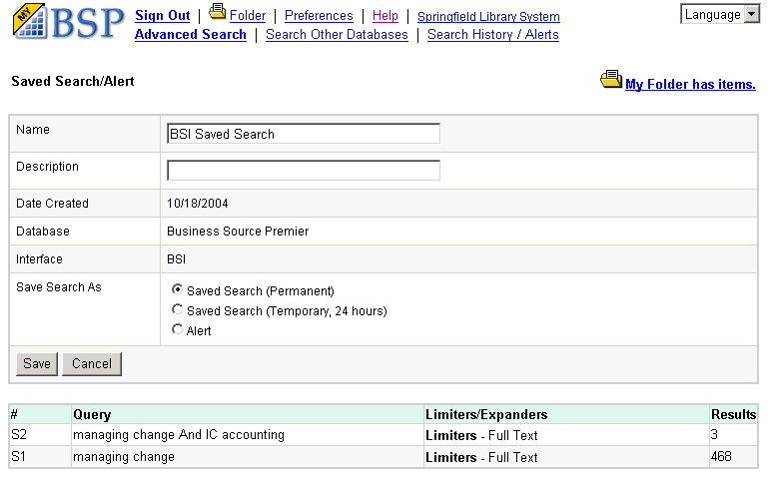
(If you have not already logged in to your personal account, you will be prompted to sign in. Enter your user name and password; or click Cancel and return to the Advanced Search Screen.)
- Enter a Name and Description for the search. (For example, mysearch1)
- In the Save Search As field, select one of the following:
  - Saved Search (Permanent)
  - Saved Search (Temporary 24 hours)
  - Alert - If you selected Alert, additional fields are available. For more information, see “Saving a Search as an Alert.”
- To save the search, click Save; otherwise, click Cancel. You are returned to the Advanced Search Screen.
You can retrieve your saved searches and alerts and edit and reuse them.

To retrieve searches:
- From the Search History/Alerts Screen, click Retrieve Searches.
- If you have not already logged into your personal account, you will be prompted to sign in. Enter your user name and password; or click Cancel and return to the Advanced Search Screen.
- If you currently have search history open, you are prompted to save your current search. If you proceed without saving, the retrieved search appears and your current search is cleared. To retrieve a search from the Saved Searches List, click on the Retrieve Saved Search link.
- You are returned to the Advanced Search Screen. The Find field now includes all information for the search you retrieved. All search counts are replaced with question marks. When you view the results (by clicking on a Rerun link in the Results column), a new search is launched and its results are added to the search history.
Note: If you retrieve a search saved on EBSCOhost into the Business Searching Interface, your results may vary. This is because the limiters may be different on either interface.

Saving a Search as an Alert
To save a search as an alert:
- From the Search History/Alerts Screen, click Save Searches/Alerts. The Saved Search/Alert Screen appears. 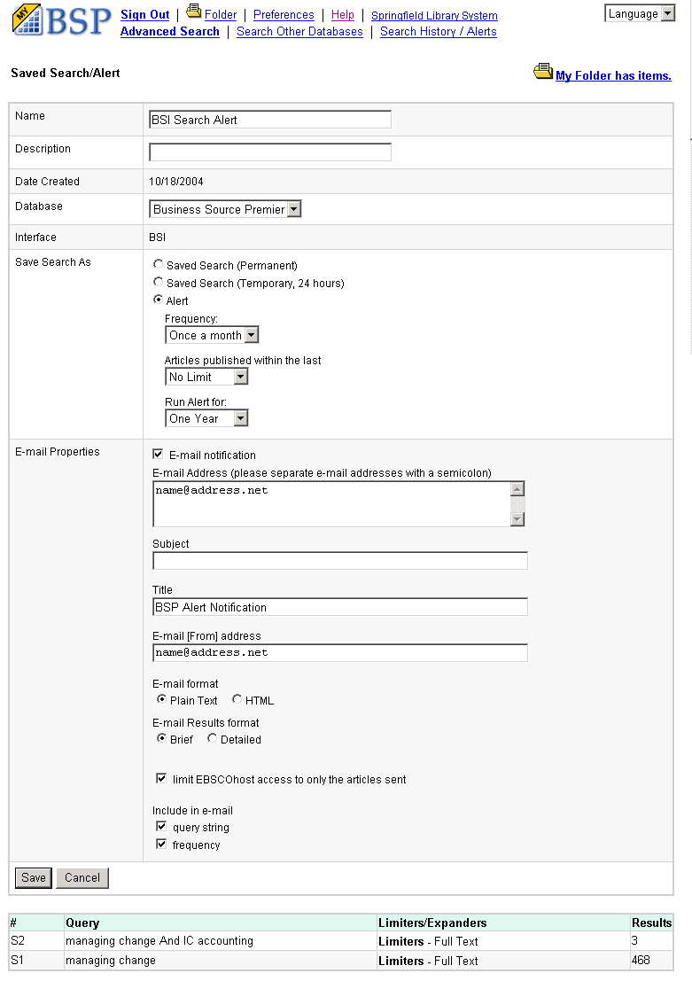
(If you have not already logged into your personal account, you will be prompted to log in. Enter your user name and password; or click Cancel and return to the Advanced Search Screen.)
- To save the search as an Alert that can be automatically run, click Alert. The Save Alert Screen appears.
- Enter a Name and Description for the Alert.
- To run the Alert against a different database, select the database from the drop-down list.
- To select how often the search will be run, from the Frequency drop-down list, select one:
  - Once a day
  - Once a week
  - Bi-weekly
  - Once a month (the default)
- To limit which articles are searched, from the Articles published within the last drop-down list, select one:
- One month
- Two months
- Six months
- One year
- No limit (the default)
- In the Run Alert for field, select one:
- One month
- Two months
- Six months
- One year (the default)
- In the Email Properties section, mark the Email notification checkbox and enter your Email Address. If you are entering multiple email addresses, place a semicolon between each email address.
- In the Subject field, enter a brief explanation that will appear in the subject line of the Alert email.
- Title - you can optionally enter a title for the email. The default value for the Title field is: BSP/BSC Alert Notification.
- Email [From] address - Defaults to: eptech@epnet.com. You can enter a different "From" email address if desired.
- Select the Email format to use: Plain Text or HTML.
- Select the Email Results format to use: Brief or Detailed.
- To limit access to only the articles sent (rather than the entire site), mark the checkbox to the left of this field.
- To have your search string included in the email, mark the Include query string in email checkbox. To include the alert frequency, mark the frequency checkbox.
- When you have finished making changes, click Save.

Setting Up a Personal Account
If provided by your library administrator, you can set up a personal account that can be used in all EBSCO interfaces. With a personal account, you can save search results, persistent links to searches, saved searches, search alerts, journal alerts and web pages to your personal folder.

To set up a personal account:
- From the Sign In Screen, click the I'm a new user link.
- The Create a New Account Screen displays with Personal Account entered in the Account Type field.
- Fill in the fields on the Create a New Account Screen. When you have completed the fields, click Continue.
- If all the information was accepted, a message appears that provides your user name and password. Click OK. You will be automatically signed in as a personal user. You should note the user name and password you created so you can log in at a future session.
When you set up a personal account, we ask for your name, email address, a unique login name, password, and password validation. EBSCO uses this information only to identify you at log in so your searches are not viewed or used by anyone else. We do not share this information. Click on our privacy policy for more information.
If you have forgotten your password, you can submit your user name to retrieve your password.

To reset your password:
  - From the Login Screen, click I forgot my password. A screen appears.
  - Enter your user name and click Continue. You are prompted to answer the question you entered as a password hint.
  - Enter your new password twice.
  - Click Continue. You are automatically signed in as a personal user based on your new password. You should note the new password so you can sign in at a future session.
If you have forgotten your user name and password, you can submit information to retrieve your user name and password.

To retrieve your user name and password:
- From the Login Screen, click I forgot my user name and password. A screen appears.
- You are prompted to enter your first name, last name and email address. Click Continue. The Reset your password screen appears with your user name displayed.
- You are prompted to answer the question you entered as a password hint, enter a new password twice.
- Click Continue. You are automatically logged in as a personal user based on your new password. You should note the new password so you can sign in at a future session.

Setting Up a Charge Back Account
If you are a corporate user (for example, a law firm or an advertising agency) who needs to track usage on a per client basis for billing purposes, you can set up a Charge Back Account. In addition to having all features available in a personal account, you can also set up clients, start a timer to track usage by client, and obtain a report of the time spent. Usage information can be printed and/or e-mailed.

To set up a charge back account:
- From the Sign In Screen, click the Create a Charge Back Account link.
- The Create a New Account Screen displays with Charge Back Account entered in the Account Type field.
- After you have completed the Create a New Account Screen click Submit. A confirmation message is displayed. Click OK.
- The Set Up New Client Screen appears. Enter the charge back information for the first client and click Submit. Your charge back information is displayed.
- You can continue entering charge back clients, or click Cancel and return to searching. You can add, change or delete charge back clients at any time.

To use charge back with Business Searching:
- Sign in using a charge back account user name and password. Your list of Charge Back clients is displayed.
- Select a client from the Charge Back List and click Start Timer. When you have finished searching for that client, click the Stop Charge Back Timer link.
- The Charge Back Report Screen displays the client name, date, and time spent searching. You can print and/or email the report.

Viewing Search Results

Viewing the Result List
Search results can be citations, full text, document summaries or abstracts, and can include links to full text.
- Each result is numbered, and the available formats for the article are displayed-–HTML Full Text, PDF Full text, or Linked Full Text. Click the linked page numbers (or forward/backward arrows) to move through the Result List.
- Where a "Sort by" drop-down list is available, you can re-sort your results by author, date, relevance, etc.
- You can change your Preferences settings (from the Utility Toolbar) to specify how many results per page should be displayed, and how much detail should be displayed for each result-–title only; a brief citation; or a detailed citation of the article.
- The article title is a hyperlink to the "best view" as selected by the library administrator-–this could be the citation; a brief citation plus full text; a PDF file; or links to full text. To view a different format, click on any of the icons listed below the title.
- Some databases present results by source type. For example, if you want to view only the magazines that were found, click the magazines icon or link.
- For each result, the folder icon is displayed to the far right. If you want to collect several articles, click the Add folder icon for the article. To add all items on a page to your folder, click Add (1-5) at the top of the Add column. Result numbers to be added will change as you page through the list of results. As you add the articles to the folder, you can click the Folder link and review which items have been added.
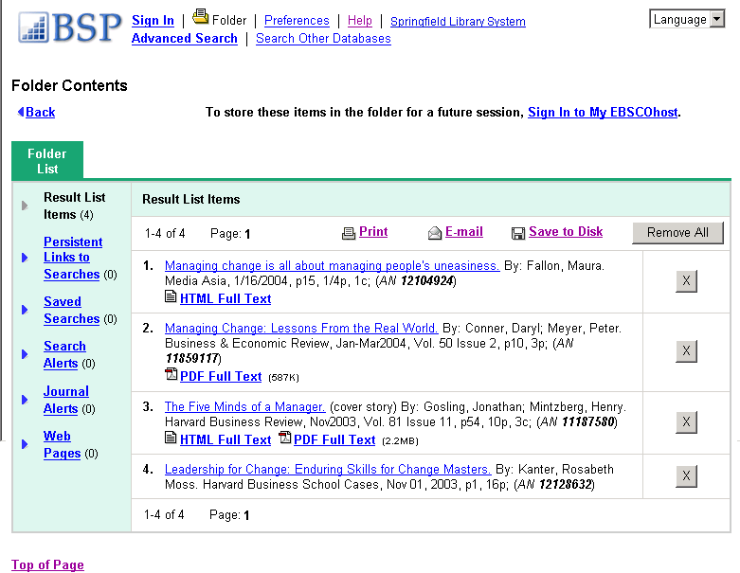
- When a Result List is displayed, an Add this search to folder icon appears to the right of your search string. You can add the query to the folder as a persistent link to a search.
- From a Result List, you can click the Display link to this search icon that appears at the end of the search string. The search query is displayed in a shaded area below the link. Highlight the link text and copy using your browser's copy function. You can immediately paste the link into a web site, document or email.
- If you have signed in to your personal account, any search results that you collect in your folder will be automatically saved at the end of the session.

Viewing the Full Record

Available Formats
When you click the title of an article, the "Best View" selected by your library administrator is displayed. This can be a citation, HTML full text or PDF. To view a different format, click on any of the icons displayed on the Formats line.

Citation View
When the citation view is displayed, it may also include a summary or an abstract. Your original keywords are highlighted throughout the record. If activated by your library administrator, the full text of the article may appear below the citation.
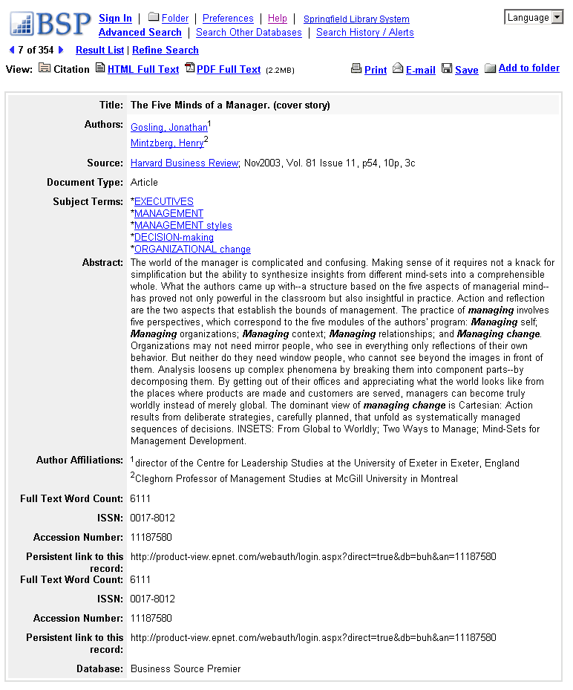
- The author and subject of the record can appear as links that let you perform a search of that particular field.
- The source may display a link or journal logo that leads to a detailed view of the source or publication. Clicking on the journal logo links you to a detailed description of the journal. Clicking Back returns you to the full record of the article.
- The source may also include a table of contents link that lets you perform a search on the same issue of the source or publication.

HTML Full Text View
When the HTML full text view is displayed, you can also return to the citation, or any PDF or linked text by clicking on the available icons. The text is displayed formatted and ready for printing. A brief citation is always included at the end of the article. 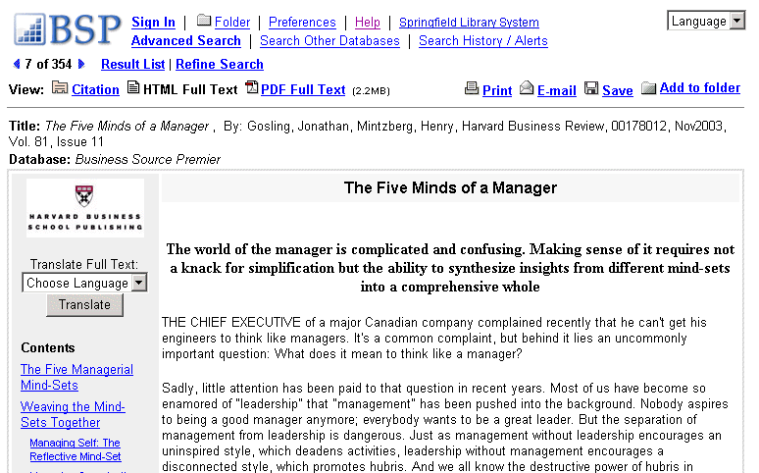 From either the citation or full text views, you can refine your search, return to the Result List, save to the folder, and print, email, or save the article.

PDF View
When the PDF view is displayed, the article opens in the Adobe Acrobat Reader. To print the article, use the print capability available from the Reader. You can also return to the citation, any full text, or linked text by clicking on the available icons. From the PDF view, you can also refine your search, return to the Result List, or email the article. 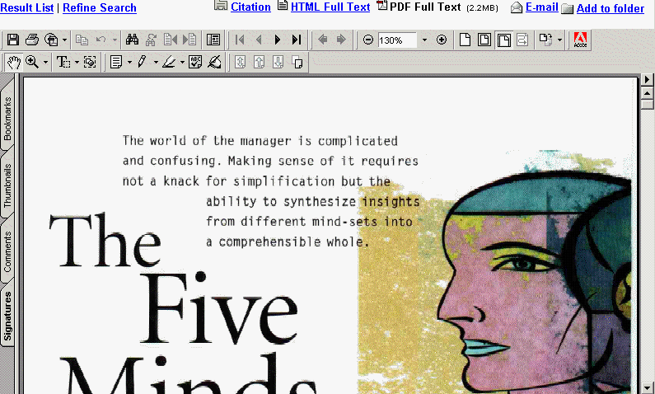

Linked Full Text View
You can link to full text articles from other EBSCOhost databases or from electronic journals subscribed to through EBSCO Subscription Services and Electronic Journals Service.
When the linked full text result is displayed, you can also return to the citation, full text, or linked text by clicking on the available icons. When you click on an available hyperlink and open full text, you can refine your search, return to the Result List, and print, email or save the article.

The Folder
The folder appears to the right of the Delivery Options. For each result, the folder icon is displayed to the far right.
To collect several articles, click the Add folder icon for the article. To add all items on a page to your folder, click Add (1-10) at the top of the Add column. Result numbers to be added will change as you page through the list of results.
As you add the articles to the folder, you can click the Folder link and review which items have been added. You can then print, email or save many results all at the same time. If you have signed in to your personal account, any search results that you collect in your folder will be automatically saved at the end of the session.

Linking to Information

SmartLinks
You can link to full text articles from other EBSCO databases or from electronic journals subscribed to through EBSCO Subscription Services using the EBSCOhost Electronic Journals Service (EJS). When checking for links, SmartLinks searches all full text databases your library administrator makes available.
SmartLinks are present in the Result List and in the Full Record when:
- The article does not contain full text or a page image (PDF) but is available in full text in another EBSCOhost database.
- The article is available in an electronic journal your institution subscribes to through EJS.
To link directly to the article, click the hyperlinked article title.

Persistent Links
Persistent linking lets users retrieve an article by clicking on a link embedded in a web site. This feature lets professors, teachers and librarians include links to articles on their web pages.
Persistent links to articles can be emailed or saved. When you email search results, persistent links to articles are automatically included with the email. Persistent links to searches can also be added to the folder and emailed or saved.
Only authorized users can access the articles. A user who cannot be authenticated is prompted with an error message indicating that he does not have the proper access rights for the article.
The library administrator activates persistent linking through EBSCOadmin.

CustomLinks
If your library supports an online public access catalog, your library administrator can make links to it available on the full record display next to the "View Links" heading.
The text of the link varies, but generally reads "Check library catalog for this item." Clicking this link takes you to your library holdings catalog page (often in a new browser window).
From this page you can see if the journal is available in your library. Depending on the features available in your library catalog, you may be able to request the item through interlibrary loan.
If made available by your library administrator, you may also be able to link to: document delivery services, book services, search engines, and other linking servers.

Using Translation Features

How Automatic Translation Software Works
Business Searching Interface screens are presented in English, by default. If provided by your library administrator, you can change the language in which all screens are displayed. You may also be able to translate a full text article from English into a variety of languages.

To change the language of the interface:
- From any Business Searching Interface Screen, select a language from the drop-down list. All screens will now display in the language you selected. Some database-specific fields may not be translated. The full text of an article will appear in the language of the database.
- To change to a different language, select another language from the drop-down list.

To translate the full text of an article:
- From the article detail, select a language from the Choose Language drop-down list. 
- Click Translate. The full text of the article is presented in the language you selected.
- To return to English, click Return.

Setting Preferences
You can change the format and sorting of your Result List by selecting Preferences from the Utility Toolbar at the top of the screen.

To set preferences:
- Select from the following Display Options available from the Search Screen and the Result List:
- How many results (or records) are displayed per page (for example: 5, 10, 20, 30, 40 or 50).
- The level of detail for each result (for example: Title only, Brief or Detailed).
- Click Apply. If you were previously at the Result List, it is updated according to your selections. If you were previously at the Search Screen, you must first perform a search before viewing the customized Result List.
Note: Preferences settings are not applied within the folder.

Saving Results to the Folder
EBSCO's Folder feature lets you collect and manage a list of search results found during your current session. You can use the folder to:
- Collect results from different searches and keep them in the folder.
- Print, email or save collected results from the folder. When you want to print, email or save several results, you should always save them to the folder, then print, email or save from the folder. (You can also print, email, or save individual results from an open article or citation.)
- You can remove specific results, or clear the entire folder and collect new results during your session. If you end your session, or it times out due to inactivity, the folder is automatically cleared unless you are signed in as a personal user.

Your Personal Folder
If you have signed in as a personalized user, you can also save search results, persistent links to searches, saved searches, search alerts, journal alerts and web pages to your personal folder. Any items that you add to your personal folder are automatically saved at the end of your session.
Note: Your library administrator decides whether personalization features are available.

Printing/Emailing/Saving

Printing Your Results

To print one or more articles or citations:
  - From the open result or from the folder, click Print. The Print Manager appears. 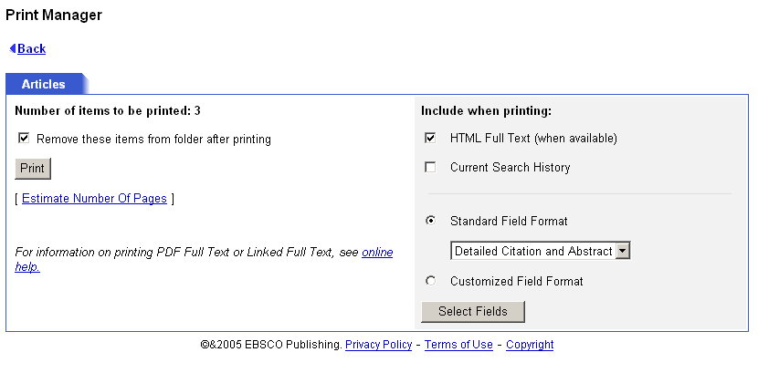
  - If you are in the folder, Remove these items from folder after printing appears. Indicate whether you want to empty the folder of all items after printing.
  - Include when printing - If you do not make any selections in this area, the defaults will apply. The Detailed Citation and Abstract (plus any available HTML Full Text) will be printed. (Most users will not need to use the "Customized Field Format" selections.)
  - HTML Full Text (when available) – Indicate whether the HTML Full Text of the article (if available) should be included.
  - Current Search History (when available) – Indicate whether the current search history should be printed with your Result List Items. (Note: It is possible that the current search history and the Result List Items may not match. If your folder contains items from a previous session, or if you've edited or cleared search history without clearing your folder, you may receive both current search history and earlier folder results.)
  - Standard Field Format - Most users will choose the default - "Detailed Citation and Abstract." You can also select from the drop-down list:
- Brief Citation – Indicates that only a brief citation should be printed.
- Brief Citation and Abstract – Indicates that a brief citation and an abstract should be printed.
- Detailed Citation and Abstract – A detailed citation and an abstract should be printed.
  - Customized Field Format - If you want to select which fields are included with your results, see Custom Fields for Print/Email/Save.
  - Click Print. The articles or citations are displayed in your browser window. Click the Print icon on the browser toolbar.
  - To return to the article or citation, click Back. If you selected more items than allowed by the library administrator, any remaining items will still be available in the folder, even if you marked Remove these items from folder after printing.
Note: If your library administrator has provided the ability to translate an article, you must print the translated article directly from your browser window.

To print PDF Full Text:
If you are printing an item that includes PDF Full Text, the PDF does not automatically format for printing from your browser window. You must open the PDF in Adobe Acrobat Reader, and use the Reader's print capability.
If the item includes a citation and/or HTML Full Text, they will print from the browser window, but you will still need to open the PDF in Adobe Acrobat Reader, and use the Reader's print capability.

To print Linked Full Text:
If you are printing an item that includes Linked Full Text, you must follow the links directly to the Full Text and then print.
If the item includes a citation and/or HTML Full Text, they will print from the browser window, but you will still need to follow the links directly to the Full Text and then print.

Saving Your Results to a File

To save one or more articles or citations:
  - From an open result or from the folder, click Save to Disk. The Save Manager appears. 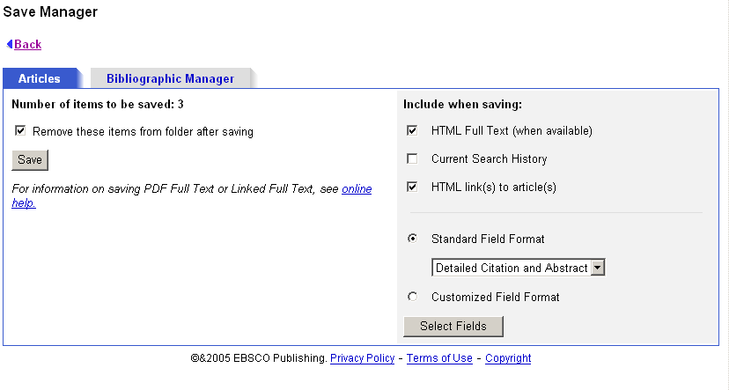
  - If you are in the folder, Remove these items from folder after saving appears. Indicate whether you want to empty the folder of all items after saving.
  - Include when saving - If you do not make any selections in this area, the defaults will apply. The Detailed Citation and Abstract (plus any available HTML Full Text and HTML links to articles) will be saved.
  - HTML Full Text – Indicate whether the HTML Full Text of the article (if available) should be included.
  - HTML links to articles – Indicate whether HTML links to the articles you have selected should be included. (To save only the persistent links to the articles, clear the Additional citation details and abstract and the HTML Full Text check boxes and be sure to mark the HTML links to articles check box.)
  - Current Search History (when available) – Indicate whether the current search history should be saved with your Result List Items. (Note: It is possible that the current search history and the Result List Items may not match. If your folder contains items from a previous session, or if you've edited or cleared search history without clearing your folder, you may receive both current search history and earlier folder results.)
  - Standard Field Format - Most users will choose the default - "Detailed Citation and Abstract." You can also select from the drop-down list:
    - Brief Citation – Indicates that only a brief citation should be saved.
    - Brief Citation and Abstract – Indicates that a brief citation and an abstract should be saved.
    - Detailed Citation and Abstract – Indicates that a detailed citation and an abstract should be saved.
  - Customized Field Format - If you want to select which fields are included with your results, see “Custom Fields for Print/Email/Save.”
  - To save the results, click Save; otherwise, click Back.
  - From your browser menu, click File>Save As. Enter the path where the file should be saved (for example, C:\Project\ResearchInfo). To save to a floppy disk, enter the path to the floppy drive (for example, A:\ResearchInfo). Be sure to save as an HTML or text file.
  - Click Save. To return to the open article or to the folder, click Back.

To save PDF Full Text:
If you are saving an item that includes PDF Full Text, the PDF does not automatically save from your browser window. You must open the PDF in Adobe Acrobat Reader, and use the Reader's save capability.
If the item includes a citation and/or HTML Full Text, they will save from the browser window, but you will still need to open the PDF in Adobe Acrobat Reader, and use the Reader's save capability.

To save Linked Full Text:
If you are saving an item that includes Linked Full Text, you must follow the links directly to the Full Text, and then save it.
If the item includes a citation and/or HTML Full Text, they will save from the browser window, but you will still need to follow the links directly to the Full Text, and then save it.

To copy a persistent link to a search:
- From a Result List, click the Display link to this search icon at the end of the search query displayed above the Find field.
- The search query is displayed in a shaded area below the link. Highlight the link text and copy using your browser's copy function. You can immediately paste the link into a web site, document or email.

To save persistent links to searches to the folder:
- From a Result List, click the Add this search to folder icon at the end of the search query displayed above the Find field. The search query is now saved in the folder as a persistent link to a search.
- From the persistent links to searches area of the folder, click Save to Disk. The Save Manager appears. A Links to Searches sub-tab is displayed.
- If you are in the folder, Remove these items from folder after saving appears. Indicate whether you want to empty the folder of all items after saving.
- Click Save; otherwise, click Back.
- From your browser menu, click File>Save As. Enter the path where the file should be saved (for example, C:\Project\ResearchInfo). To save to a floppy disk, enter the path to the floppy drive (for example, A:\ResearchInfo). Be sure to save as an HTML or text file.
Note: The library administrator decides whether the persistent links feature is available.

Emailing Your Results

To email one or more articles or citations:
  - From the open result or from the folder, click Email. The Email Manager appears. 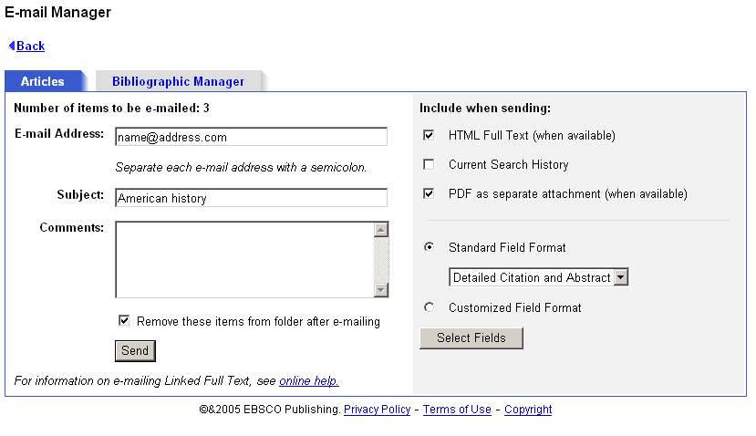
  - Enter the Email Address. To send to more than one email address, use a semicolon between each email address. (For example, name1@address.com; name2@address2.com).
  - Enter a Subject to appear on the email subject line. (For example, Results of research on topic ABC.) (40-character maximum.)
  - Enter any Comments you would like to include with your email.
  - If you are in the folder, Remove these items from folder after emailing appears. Indicate whether you want to empty the folder of all saved items after emailing.
  - Include when sending - If you do not make any selections in this area, the defaults will apply. The Detailed Citation and Abstract (plus any available HTML Full Text and PDF Full Text) will be sent. (Most users will not need to user the "Customized Field Format" selection.) Persistent links to articles are automatically included in the email.
  - HTML Full Text (when available) – Include the HTML Full Text of the article, if available.
  - PDF as a separate attachment (when available) – Include all citation information and the article in Adobe PDF format, if available.
  - Current Search History (when available) – Indicate whether the current search history should be emailed with your Result List Items. The history will be delivered as a separate HTML attachment. (Note: It is possible that the current search history and the Result List Items may not match. If your folder contains items from a previous session, or if you've edited or cleared search history without clearing your folder, you may receive both current search history and earlier folder results.)
  - Standard Field Format - Most users will choose the default - "Detailed Citation and Abstract." You can also select from the drop-down list:
- Brief Citation – Indicates that only a brief citation should be emailed.
- Brief Citation and Abstract – Indicates that a brief citation and an abstract should be emailed.
- Detailed Citation and Abstract – Indicates that a detailed citation and abstract should be emailed.
- Customized Field Format - If you want to select which fields are included with your results, see “Custom Fields for Print/Email/Save.”
- To send the email, click Send; otherwise, click Back. A message appears when your email has been sent. If you selected more items than allowed by the library administrator, any remaining items will still be available in the folder, even if you marked Remove these items from folder after emailing.

To email Linked Full Text:
If you are emailing an item that includes Linked Full Text, you must follow the links directly to the Full Text and then email it. Otherwise, only the citation and any available HTML Full Text will be sent. If you follow the links to the Full Text and it is PDF format, the PDF will be sent as an attachment to the email.

To email persistent links to searches:
  - From a Result List, click the Add this search to folder icon at the end of the search query displayed above the Find field. The search query is now saved in the folder as a persistent link to a search.
  - From the Persistent Links to Searches area of the folder, click Email. The Email Manager appears. A Links to Searches sub-tab is displayed.
  - Enter the Email Address. To send to more than one email address, use a semicolon between each email address. (For example, name1@address.com; name2@address2.com.)
  - Enter a Subject to appear on the email subject line. (For example, Results of research on topic ABC.) (40-character maximum.)
  - Enter any Comments you would like to include with your email.
  - If you are in the folder, Remove these items from folder after emailing appears. Indicate whether you want to empty the folder of all items after emailing.
  - Click Send; otherwise, click Back.
  - A message appears when your email has been sent. If you selected more items than allowed by the library administrator, any remaining items will still be available in the folder, even if you marked Remove these items from folder after emailing.
Note: The library administrator decides whether the persistent links feature is available.

Custom Fields for Print/Email/Save
Most users will want to include the Standard Fields for the database being searched when printing, emailing or saving search results. If you would like to select the fields to be included within your print, email or save output, you can make these selections in the Customized Field Format area of the Print/Email/Save Managers.

To customize which fields are included with print/email/save:
  - From the Print, Email or Save Manager, select Customized Field Format and click the Select Fields button.
  - On the Select Fields for Output screen, mark the check boxes to the left of the fields you want to include. The fields shared by all the databases you are searching appear in the Fields in Common area at the top of the screen. The individual databases are displayed in alphabetical order, with a maximum of five databases per page. You can use the page numbers or navigation arrows to view additional lists of database fields.
  - Click Continue, or click Cancel to discard your changes. Your selections will be retained throughout the session for all print, email, or save activity. If you want your selections retained for a future session, be sure to sign in as a personal user.
  - Continue printing, emailing or saving your search results.
Notes:
- The Customized Field selections do not apply to output using the Bibliographic Manager.
- If you use the Customized Field Format option, the estimated number of pages to be printed, emailed or saved is not available.

Creating a Bibliography
The Bibliographic Manager download option lets researchers download one or more results to a format compatible with BiblioLink® and ProCite® (as well as other data management programs).
Saving your results to a file using this option creates a text file with a special tagged format that BiblioLink and ProCite can import and transfer for use with their software.

What is a Bibliographic Manager?
Bibliographic managers are databases that let a user search for relevant references on a particular subject. They are loaded with articles from a library database, an online service or from another user. Searches are then conducted to locate all relevant references to a subject in question. Finally, articles can be exported to a word processor for formatting.
For example, before importing into ProCite, one result of a search in the output text file looked as follows:
DE- HALLOWEEN decorations -- Design
TI- String-Art Winifred witch.
JN- Crafts & Things
PD- Oct96, Vol. 22 Issue 1, p21
PG- 2p IS- 7bw
AU- Swanson, Barbara
AB- Gives directions for making a whimsical witch from balloons and strings, with pattern included. Shaping body pieces; Finishing instructions.
After importing into ProCite, a reference list can be added to a research paper (see item #5):
- Adams Kathleen; Barrett Robertson, and et, a. l. The 10 most popular Halloween costumes sold last week at Toys `R' Us. Time. 1994 Oct 31; 1-9p.
- Howard Lucy and Hamilton Kendall. Fog 'n' figures. Newsweek. 1994 Nov 14; 1-6p.
- Smith, A. n. n. Watch that witch. Progressive Grocer. 1975 Oct; 1-7p.
- Smolen Wendy. Tricks and treats! Parents. 1971 Oct; 22p.
- Swanson Barbara. String-Art Winifred witch. Crafts & Things. Oct96, Vol. 22 Issue 1, p21; 2p.

Saving a Bibliography File

To create a bibliography file from your results:
    - From the open article or citation, or from the folder list, click Save to Disk. The Save Manager appears.
    - Click the Bibliographic Manager tab. The Bibliographic Manager appears.
    - If you are in the folder, Remove these items from folder after saving appears. Indicate whether you want to empty the folder of all items after saving.
    - Include when saving - select one of the following:
  - Citations in a format that can be uploaded to bibliographic management software - includes all fields available with a citation.
  - Citations in Direct Export format - includes those fields supported by ISI's Direct Export technology. (This would be useful if you are at a remote location and have bibliographic management software such as ProCite® or EndNote® on your home or office computer. You could save your citations at a school or public library and import them into your citation library at home.)
  - Direct Export to RefWorks - exports citations directly to RefWorks web-based bibliographic management software. (Your library must have a subscription to RefWorks to use this option.)
5. To save the results, click Save.
- If you saved your citations in a format that can be uploaded to bibliographic management software, the articles and citations are displayed in your browser window. Save from your browser window. Be sure to enter the path where the file should be saved (for example, C:\Project\ResearchInfo). To save to a floppy disk, enter the path to the floppy drive (for example, A:\ResearchInfo). Be sure to save as an HTML or text file. Click Save.
- If you saved in Direct Export format and bibliographic management software (such as ProCite® or EndNote®) is installed on your computer, that software should automatically open. You should be able to indicate whether to add the citations in the export.txt file to a new or existing citation library.
Notes:
- For more information, you should review the bibliographic software documentation.
- Some browser versions include a pop-up blocking feature. If you are using RefWorks, you should enable your browser to allow pop-ups from epnet.com servers.
- The Bibliographic Manager does not support the Customized Fields feature.

Emailing a Bibliography File

To email a bibliography file of your results:
- From the open article or citation, or from the folder list, click Email. The Email Manager appears.
- Click the Bibliographic Manager tab. The Bibliographic Manager appears.
- Enter the Email Address. To send to more than one email address, use a semicolon between each email address. (For example, name1@address.com; name2@address2.com).
- Enter a Subject to appear on the email subject line. (For example, Citations for topic ABC.) (40-character maximum.)
- Enter any Comments you would like to include with your email.
- If you are in the folder, the Remove these items from folder after emailing option is displayed. Indicate whether you want to empty the folder of all saved items after emailing
- Include when sending - select one of the following:
  - Citations in a format that can be uploaded to bibliographic management software - includes all fields available with a citation.
  - Citations in Direct Export format - includes those fields supported by ISI's Direct Export technology. (This would be useful if you are at a remote location and have bibliographic management software such as ProCite® or EndNote® on your home or office computer. You could email yourself citations at a school or public library and import them into your citation library at home.) Persistent links to the records are automatically included in the email and the export file.
- To email the results, click Send.
Notes:
- For more information on exporting files to bibliographic management software, you should review that product's documentation.
- The Bibliographic Manager does not support the Customized Fields feature.

