
EBSCOhost User Guide
Academic Search™ Databases

Table of Contents
What is Academic Search™ 4
Academic Search™ Elite 4
Academic Search™ Premier 4
What is EBSCOhost® 4
System Requirements 4
Choosing Databases to Search 5
Using the Toolbar 5
Using the Utility Toolbar 5
The Sub-Toolbar 6
The Tabbed Toolbar 6
Using the Basic Search Screen 6
Performing a Basic Search 6
Refine Search Options 7
Using the Advanced Search Screens 8
Advanced Search: Single Find Field 8
Advanced Search: Single Find Field and Search Builder 8
Advanced Search: Guided Style Find Fields 9
Search History/Alerts Tab 10
Search Techniques 11
Sub-Toolbar Options 13
Searching by Publication 13
Searching the Subject Terms 15
Searching by Indexes 17
Searching by Cited References 18
Searching for Images 19
Result List Features 20
Persistent Link to Searches 20
Print/E-mail/Save Options 21
Browsing Cited References 21
Detailed Citation Features 24
HTML Full Text Features 26
My EBSCOhost® and Page Composer 27

What is Academic Search™
There are two different Academic Search databases available: Academic Search ™Elite and Academic Search ™ Premier.

Academic Search™ Elite
Academic Search™ Elite is a multi-disciplinary full text database. This scholarly collection offers information in many areas of academic study, such as social sciences, humanities, education, computer sciences, engineering, physics, chemistry, language and linguistics, arts & literature, medical sciences and ethnic studies. In addition to journal coverage, Academic Search™ Elite provides full text information from a variety of source types, such as scholarly monographs. The majority of full text titles are native (searchable) PDFs or scanned-in-color. Full text information in this database dates back to 1985.

Academic Search™ Premier
Academic Search™ Premier, designed specifically for academic institutions, is the world's largest scholarly, multi-disciplinary full text database. This collection offers information in many areas of academic study, such as social sciences, humanities, education, computer sciences, engineering, physics, chemistry, language and linguistics, arts & literature, medical sciences and ethnic studies. Academic Search™ Premier is a vast collection of the most valuable peer-reviewed full text journals, offering critical information from many sources unique to this database. Academic Search™ Premier provides expanded indexing & abstracts and PDF backfiles for more than 100 top scholarly academic journals, dating back to 1965 or the first issue published (whichever is more recent). Many of the PDFs are native (searchable) or scanned-in-color.

What is EBSCOhost®
EBSCOhost® is a powerful online reference system accessible via the Internet. It offers a variety of proprietary full text databases and popular databases from leading information providers. The database types range from general reference collections to specially designed, subject-specific databases for public, academic, medical, corporate and school libraries.

System Requirements
To effectively use EBSCOhost features, the minimum browser requirements are Internet Explorer 5.0 or higher and Netscape 4.7 and above. If you are using below the minimum requirements for Netscape or Internet Explorer, or using a Lynx browser, please use the EBSCOhost Web Text Only Interface.
Note: You must have Adobe Acrobat® installed to view the PDF Full Text files.

Choosing Databases to Search

To search a single database - Click directly on the database name link, e.g., Academic Search™ Premier. The search screen appears.

To search several databases - Click on the check boxes located to the left of the databases you want to search. Click Continue. The search screen appears.
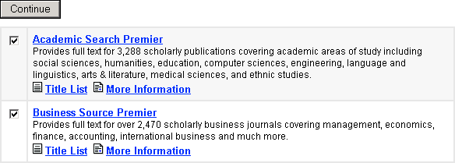
You can access database-specific help from within the search screens and on the Result List screen. Beneath the database names at the top of each of these screens is a link entitled Database Help. If you are searching more than one database, the Database Help Screen appears, from which you can choose the specific database help.
You can also access database-specific help by clicking on the More Information link on the Choose Databases Screen. From the Choose Databases Screen, the Title List link connects to the Publication Authority file.

Using the Toolbar
EBSCOhost® offers a toolbar for functions that are available at all times during a search session. There may be more options, depending upon the database you are searching.
Utility Toolbar
Tabs

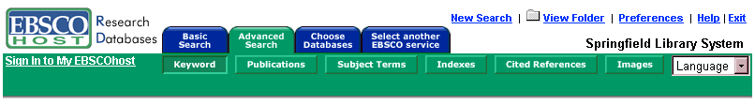
Sub-Toolbar

The function of each tab and button is explained throughout this guide.

Using the Utility Toolbar
- New Search – This link will return you to the default search screen.
- View Folder – This link will display results placed in the folder. (Note: If you are not signed in to My EBSCOhost, your folder will clear when your session ends.)
- Preferences – This link allows you to change the Result List format and number of results per page.
- Help – This link opens the Online Help Manual.
- Exit/Home Library – This link will only appear if no home library graphic and URL are available. Click Exit to log out of EBSCOhost.
- Home Library Graphic – Click on the library graphic or logo to return to the library home page.

The Sub-Toolbar
The sub-toolbar is available on the search screens and will vary depending on the database and features your library administrator selects. Keyword, Subject and Publication authority files are displayed on the sub-toolbar for both the Basic and Advanced Search Screens.
The Language drop-down list allows you to translate the search screen, tabs, buttons and citation field descriptors into Spanish, French, German, Italian, Portuguese, Russian, Korean, Japanese, Simplified Chinese or Traditional Chinese. (For more information about multilingual options, please download the EBSCOhost Multilingual User Guide.)
The function of each option on the sub-toolbar is explained throughout this guide.
Note: When searching multiple databases, database-specific authority files (Publications, Subjects, Author, Indexes, References, etc.) will not appear.

The Tabbed Toolbar
From the Tabbed Toolbar, you can select the Basic or Advanced Search Screen, click the tab you are on to clear your search terms and start over, or choose other databases to search. If available, you can select from other EBSCO services to which your institution subscribes.

Using the Basic Search Screen

Performing a Basic Search
To perform a search, enter your term(s) in the Find field and click Search. Click Clear to remove any term(s) located in the Find field. The Clear button does not remove any limiters selected in the Refine Search Tab.
You can use Boolean operators, field codes, truncation (*), wildcard (?) and quotation mark search phrasing when performing a Basic Search. All results are in reverse chronological order, beginning with the most current item. Boolean Search techniques are explained in the next section.

Refine Search Options
Limiters and Expanders can be used to focus or broaden a search.
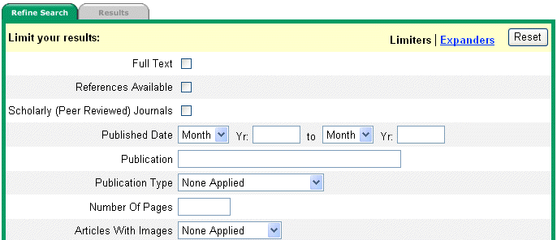
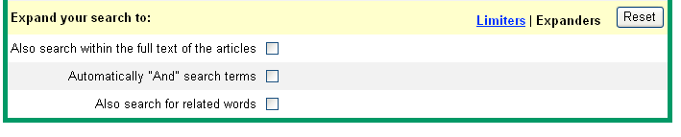
Limiters: Examples of limiters for Academic Search databases include: Full Text, Scholarly (Peer Reviewed) Journals, Publication and Published Date.
When you select one of the above limiters, that limiter focuses your search. For example, if you search on technology and check the Full Text limiter, only full text articles will appear in the Result List.
Expanders: Expanders for Academic Search include:
- Also search within full text of the articles expands results by searching for your term(s) within the full text of the articles.
- Automatically “And” search terms expands search results by applying the AND operator between terms. For example, if you search on economic development and set the expander to Automatically “And” search terms, only articles that contain economic and development will appear in the Result List.
- Also search for related words expands search results to include synonyms and plurals of your term(s).
Various search techniques can be used, including: Wildcard, Truncation, Proximity Searching and Grouping Parentheses. These techniques are described in the next section.
Note: The Reset button will clear all items selected from the Refine Search Tab.

Using the Advanced Search Screens
The library administrator chooses one of three available Advanced Search Screen styles: Single Find Field, Single Find Field with Search Builder, or Guided Style. All three Advanced Search Screens have the following options available:
- Limiters: Examples of limiters for Academic Search databases include: Full Text, Scholarly (Peer Reviewed) Journals, Publication and Published Date.
- Expanders: Expanders for Academic Search include: Also search within the full text of the articles, Automatically “And” search terms, and Also search for related words.
- Special Limiters are database-specific and will appear in separate sections when you conduct a multi-database search.

Advanced Search: Single Find Field
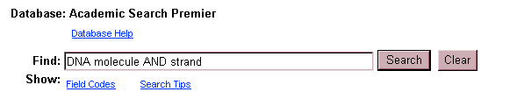

To perform a Single Find Field search:
- From the default search screen, click the Advanced Search Tab.
- In the Find field, enter keyword(s).
- Apply limiters or expanders, using the Refine Search Tab
- Click on the Search button.
In the Single Find Field, you can combine terms together (using Boolean operators) on a single line. For example, type DNA molecule AND strand.

Advanced Search: Single Find Field and Search Builder
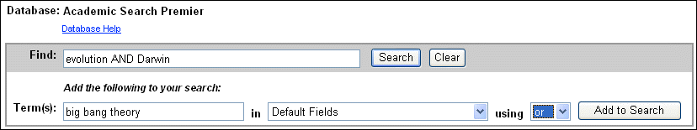
Single Find Field with Search Builder allows you to combine keywords, search fields and a Boolean operator with any existing text in the Find field.
Note: If there is no existing text in the Find field, the Boolean operator selection is ignored.
Each time you click Add to Search, the new terms are surrounded by parentheses.

To perform a Single Find Field with Search Builder search:
- Type: evolution AND Darwin in the Find field.
- Type: big bang theory in the Term(s) field.
- Select which field to search within, from the drop-down list.
- Choose OR as the Boolean operator.
- Click Add to Search.
These steps result in: (evolution AND Darwin) and (big bang theory).

Advanced Search: Guided Style Find Fields
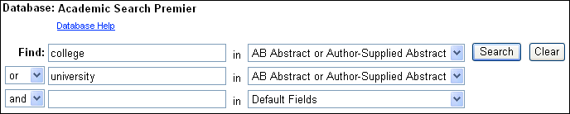
Guided Style Find Fields provides fill-in-the-blank keyword searching to aid in complex or specific searches.
To perform a Guided Style Find Fields search:
  - Enter a search term in the first Find field.
  - Choose the Search field from the drop-down list beside it.
  - Select a Boolean operator to combine the next term.
  - Enter another term in the next Find field.
  - Choose the Search field from the drop-down list beside it.
  - Click Search.
Using Guided Style Find Fields, you can also combine terms together on a single line. For example, type college OR university for results containing the word college or university.

Search History/Alerts Tab
From the Advanced Search Screen, you can save, retrieve and reuse your advanced searches. You can view these searches from the Search History/Alerts Tab. New searches can consist of combined or modified searches.
Note: You can save your search history for later retrieval or create an alert from your last search utilizing My EBSCOhost. Please refer to the My EBSCOhost and Page Composer User Guide for more information.
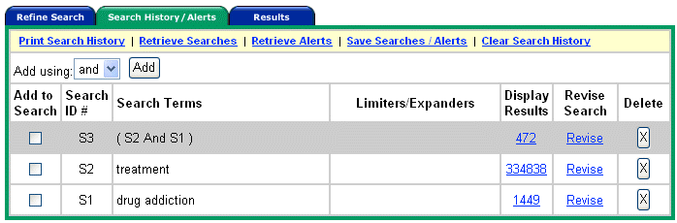
The following columns are present in the Search History/Alerts Tab:
- Add Using – Choose the Boolean operator to use when combining searches.
- Add to Search – Click on the box to the left of any Search ID that you would like to include in a new search.
- Search ID # - This column contains the number assigned to each of your searches. You can conduct a search by entering the Search ID number and prefix (S), in the Find field and clicking Search. (For example, S1 or S3.)
- Search Terms - This column contains the search terms as you entered them in the Find field, including any field codes and Boolean operators.
- Limiters/Expanders - The limiters and expanders used in your search are listed in this column.
- Display Results - The total number of search results is shown here. When you click on this number, the Result List for the search appears. Searches that do not produce results are included in the Search History and display a zero in this column. When you change or add databases, searches saved in the current database display question marks in the Display Results column.
- Revise Search - When you click on the Revise link, the search terms are displayed in the Find field. Edit the search by changing terms manually, entering field codes or adding limiters or expanders.
- Delete - To remove a search string, click on the X button next to it.
Your Search History includes only the searches from the current EBSCOhost® session that used the Advanced Search Screen. By default, the Search History displays your most recent five searches. When you have conducted more than six searches, you can select the Show More link to open all the searches you have performed in your EBSCOhost session. Select the Show Less link to view only the last five searches. When your session ends, the Search History is deleted.
If you change databases, your Search History will be saved. However, if you open another EBSCO service, such as Searchasaurus® or NoveList®, your Search History will not be saved.
In addition, your Search History is affected when you change databases. Searches must be performed with the limiters available in the databases you open. The Display Results column displays question marks when the Advanced Search Screen is opened in the new database. When you view the results by clicking on the link in the Display Results column, a new search is launched and its results are then added to the Search History.
Note: Searches conducted from the Basic Search Screen are not saved to the History file.

Search Techniques
Boolean Searching
Boolean logic defines logical relationships between search terms. The Boolean search operators AND, OR and NOT allow you to broaden or focus your search results.
- The AND operator combines search terms so that each result contains all of the terms. For example, Darwin AND evolution will result in articles that contain both Darwin and evolution.
- The OR operator combines search terms so that each result contains at least one of the terms. For example, college OR university will result in articles that contain either college or university.
- The NOT operator excludes search terms so that each result will not contain any of the terms that follow it. For example, cloning NOT sheep will result in articles that contain the term cloning, but not the term sheep.
The Wildcard (?) and Truncation (*) Symbols
Use the wildcard and truncation symbols in searches using terms with unknown characters, multiple spellings or various endings.
Note: Neither the wildcard nor the truncation symbol can be used as the first character in a search term.
- The wildcard is represented by a question mark (?). To use the wildcard, enter the search terms and replace each unknown character with a (?). EBSCOhost will provide results containing variations of that character set, with the “?” replaced by a letter.
For example, type ne?t to find all citations containing neat, nest or next. EBSCOhost will not find net because the wildcard replaces a single character.
- Truncation is represented by an asterisk (*). To use truncation, enter the root of a search term and replace the ending with an asterisk (*). EBSCOhost will find all available forms of that word.
For example, type comput* to find the words computing or computation.
Proximity Search
A Proximity Search produces results with two or more terms that appear a specified number of words (or fewer) apart in the database(s). The proximity operator is composed of a letter (N or W) and a number (to specify the number of words), placed between search terms.
- Near Operator (N) - N5 will find a result if the terms are within five (5) words of each other, regardless of the order in which they appear.
For example, type education N5 reform for results that contain education reform, as well as reform education in public schools.
- Within Operator (W) - W8 will find a result if the terms are within eight (8) words of each other, in the exact order entered.
For example, type education W8 reform for results that contain education reform, but not reform education in public schools.
Grouping Terms Together Using Parentheses
Parentheses can be used to control a search query. Without parentheses, a search is executed from left to right. However, words enclosed in parentheses are searched first.
Why is this important? Parentheses allow you to define the way the search will be executed. The left phrase in parentheses is searched first; then, based upon those results, the second phrase in parentheses is searched.
Generalized Search: state or federal and return or refund
Focused Search: (state or federal) and (return or refund)
In the first example, the search will retrieve results on state, as well as references to the terms federal and return, and everything on refund.
In the second example, parentheses control the query to only find articles about state or federal that reference return or refund.
Spell Checker
EBSCOhost® automatically checks for commonly misspelled words when a search is performed and will suggest alternate spellings.

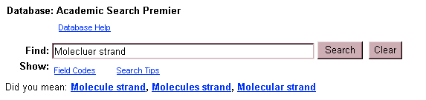

Sub-Toolbar Options
As an alternative to keyword searching, EBSCOhost® offers the capability to search a database by browsing a list of publications, subjects and other indexes.

Searching by Publication
The Publications Authority File lists the information contained in a database according to journal or magazine name.
You can browse a list of publications or perform a search on several publications for a specific database.

To browse a Publications Authority File:
- Click the Publications sub-toolbar button. The Publications Authority File appears, with the beginning of the list displayed.
- From the Publications tab, enter your search terms in the Browse for field. You can enter all or part of a publication name, for example, Harvard Business Review.
- Select a search type by clicking the radio button next to:
- Alphabetical – This search type finds journals beginning with the letters entered. Results are displayed in alphabetical order.
- By Subject – This search type allows users to search directly on the subject of a journal.
- By Subject & Description – This search type allows users to simultaneously search the subject, description and title fields of a journal.
- Match Any Words - This search type finds publications containing one or more of your terms. Results are displayed in order of relevance.
- Click Browse to view your terms as they appear in the Publications Authority File. A Result List is displayed.
Click on the name of the publication to view the title, publisher's address and dates of coverage.
The Publication Overview Screen includes the following information (if available): journal title, ISSN, frequency, annual subscription price, publisher's address, publisher's URL (Internet address), the subject and/or a description of the journal, whether the journal is peer reviewed, and if the publication is held locally at the library.
You can view all articles within a particular volume and issue by using the view tree (clicking the + sign next to the year).
Note: Over time, the name of a publication may change. EBSCOhost will display the title's current name and include any title name changes within the detailed display. A user can choose to view All Issues for the various name changes, or just the issues for the current title name by clicking on Current Issue Only.
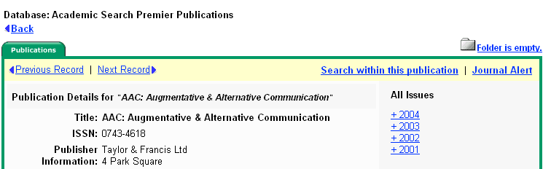

To search within several publications simultaneously:
- With the Publications Result List displayed, click the Mark Items for Search tab.
- Mark the check boxes to the left of the publications you want to search. Click Add. The publications you selected are placed in the Find field on the search screen. (They are combined with OR.)
- To search within those publications, click Search.
- To revise your search, add more terms in the Find field and click Search.
You can click Search to obtain results from several publications. You can also edit your search in the Find field, adding and humanity to your search, for different results.

To search within this publication:
- From a journal's Publication Overview Screen, click the Search within this publication link.
- The search screen appears with the JN tag and the journal name entered in the Find field (e.g., JN “Time”).
- Add any additional search terms and/or limiters.
- Click Search. A Result List is displayed.
Note: If you are defaulted to the Basic Search Screen after clicking on the Search within this publication link, you must use a Boolean operator (AND, OR, or NOT) to combine the search terms with the journal name.
To set up a Journal Alert:
Note: You must have an account and have logged in to My EBSCOhost to use this feature.
- From the journal's Publication Overview Screen, click the Journal Alert link. If you have not logged in to My EBSCOhost, you will be prompted to do so.
- The Journal Alert Screen appears, on which the (Journal Alert) Name, Date Created and Database name have automatically been filled in.
- In the Run Alert for field, select how long the Journal Alert should run:
- One month (the default)
- Two months
- Six months
- One year
- In the E-mail Address field, enter your e-mail address. Separate multiple e-mail addresses with a semicolon.
- Enter a subject for the e-mail.
- Enter a title for the alert, which will appear in your My EBSCOhost personal folder. The default value for the title field is: EBSCOhost Alert Notification.
- Enter the e-mail address the alert will come from, as a reminder to the recipient.
- Choose the desired e-mail format (Plain Text or HTML.)
- Select whether you want the e-mail to include: Link to TOC page on EBSCOhost or Article links embedded within the e-mail message.
- Choose between the Brief or Detailed citation format, if articles links will be included.
- Click to limit EBSCOhost access to only those articles sent.
- To have your search string included in the e-mail, check query string.
- Click Save. You are returned to the Publication Overview Screen. A message is displayed that indicates a Journal Alert has been set up for the publication. You can edit your Journal Alerts by accessing them from within your personalized folder.

Searching the Subject Terms
You can browse a list of subjects using the Subject Terms sub-toolbar button.

To browse the Subject Terms:
  - Click the Subject Terms sub-toolbar button.
  - Enter your search terms, for example academic achievement, in the Browse for field.
  - Click Term Begins With to list your search results in alphabetical order. Click Term Contains to list results that’s title contains your entered word. Click Relevancy Ranked to list your search results according to relevance.
  - Click Browse to view your terms as they appear in the Subject Terms Authority file.
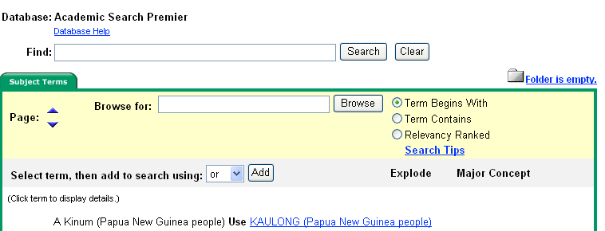
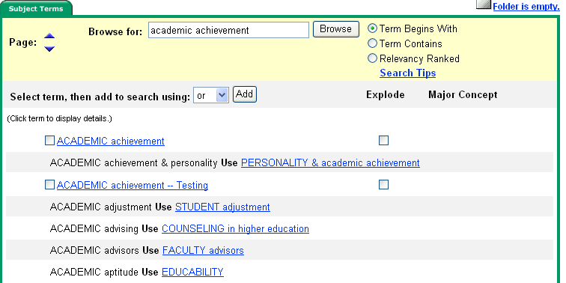

Using Explode
When you check the Explode box next to a search result, the term is exploded to retrieve all references indexed to that term, as well as all references indexed to any narrower terms. The following options may appear:
Broader Terms – This is the main subject term that your search term appears under, as a narrower term. Using Explode will add the main subject term and all narrower terms of it in the Find field.
Narrower Terms – These terms represent a subset of the original search term(s). When you click on the Explode box next to your term, the word is exploded to retrieve all references indexed to that term, as well as all references indexed to any narrower terms.
Related Terms – A thesaurus is used to display words that are similar to the original search term(s).
Used for - The Subject Terms will occasionally provide correct search term suggestions. For example: Scholastic success is listed as Academic achievements. The Used for area will display the list of terms that refer to the correct academic term.

Searching by Indexes
Browse a list of indexes to view the database’s citation fields.
Note: Unless otherwise specified by your library administrator, Index Browse is only available from the Advanced Search Screen.

To search by Indexes:
- Click the Indexes sub-toolbar button.
- Choose the field you would like to view from the drop-down list, for example: Document Type.
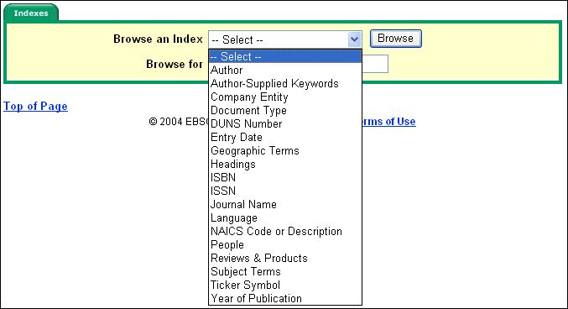
- Enter your search term in the Browse for field, for example: proceeding.
- Click Browse to view the results in alphabetical order, beginning with your selected term.
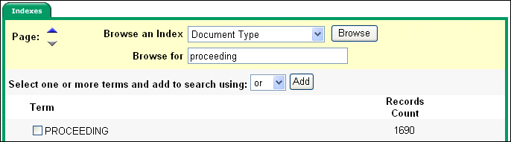
- Click the box in front of the term you want to select. Repeat steps 2-4 to add more items to the Browse for field, then click Search to view the results.

Searching by Cited References
EBSCOhost® allows users of Academic Search® Premier to browse and search by cited references.

To search by Cited References:
    - Click the Cited References button from the sub-toolbar. The Cited References Screen appears.
    - Enter search terms in the Cited Author, Cited Title, Cited Source, Cited Year or All Citation Fields fields, and then click Search.
The results of a cited reference search are displayed below the Cited References sub-tab. The search fields remain available so you can edit your search terms or conduct a new search.
- Cited References – From the Cited References Search Screen, the Cited References sub-tab presents a list of citation records for the search terms you entered.
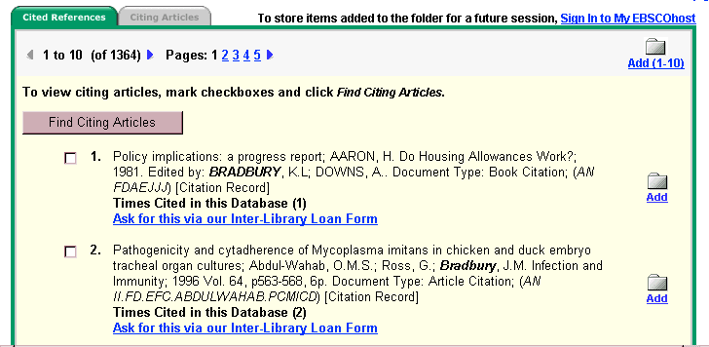
- Citing Articles – From the Cited References sub-tab, you can mark check boxes, click the
Find Citing Articles button and retrieve a list of Citing Articles.
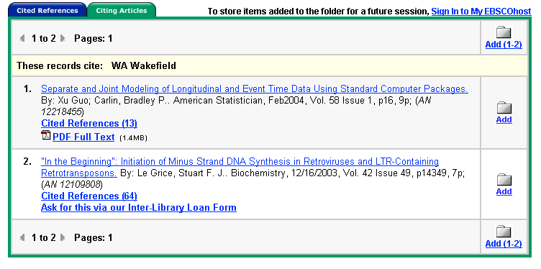

Searching for Images
The Image Collection provides you with instant access to more than 115,000 worldly images relating to people, natural science, places, history, maps and flags. The images are organized by category to simplify the search process.
You can focus your image search using the categories available on the search screen: Photos of people, Natural science photos, Photos of places, Historical photos, Maps, and Flags. You can select more than one of these categories, for example: Maps and Flags. When no specific category is selected, all categories are searched.

To search for an image:
- Click the Images sub-toolbar button. The Image Collection Search Screen appears.
- Enter your search terms in the Find field, for example: Eleanor Roosevelt.
Your search term(s) must exactly match a word in the title or caption of an image; the search term Roosevelt does not yield the same results as the search terms Eleanor Roosevelt. You can use Boolean terms to broaden your search, for example: Eleanor AND Roosevelt.
- Select from the available categories to focus your search. If you make no selections, all categories will be searched.
- Click Search. A Result List consisting of thumbnail images with brief descriptions appears.
- To print an image, click on the thumbnail image and click Print. The Print Manager Screen is displayed. Click Print.
- To save the image, click on the thumbnail image and click Save to Disk. The Save Manager Screen is displayed. Click Save, and then save from your browser window.

Result List Features
The Result List displays search results in reverse chronological order and displays the total number of results above and below the results, on the left side. You can sort results by Date, Source, Author or Relevance using the Sort by: drop-down list.
Note: Sorting by result type will repaint your Result List with only that source type.
- Navigation arrows allow you to access the next or previous page of results. The numbers allow you to go directly to a specific page.
- The links for Scholarly Journals, Magazines, Monographs/Reference Books and Educational Reports allow you to view just the articles available in those types of publications.
- PDF Full Text displays an image of the article (in Portable Document Format) exactly as it appeared in the original publication.
- HTML Full Text represents full text availability in the HTML format.
- The camera icon signifies that there is an embedded image available within the full text of the article. These images may include color or black & white photos, graphs, diagrams or charts.
- Linked Full Text (when enabled) will bring you to the full text of an article, if available from alternate sources, e.g., other EBSCOhost databases you subscribe to, EJS, or CrossRef.
- Cited References are notes in a publication that refer you to another source the author used when writing the article. If you click the Cited References link for an article, the Cited References sub-tab presents a list of records cited in your original article.
- Times Cited in this Database indicates the number of times the article was cited in other articles. If you click the Times Cited in this Database link for an article, the Citing Articles sub-tab presents a list of records that cite your original article.
- Add allows you to add a single result to your folder.
- Add (1-10) allows you to add all results on the page to your folder.
Note: For more information on folder functionality, please refer to the My EBSCOhost and Page Composer User Guide.

Persistent Link to Searches
Once a search has been performed, you can add a persistent link to a search to the folder. The link to a search can be e-mailed or saved, and will allow you to conduct the search again by clicking on the link, or entering it in the address field. To add a link to your folder, click on the Add this search to folder link next to the search string.
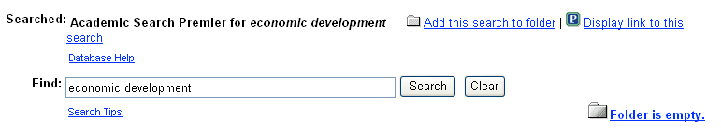

To view the persistent link to the current search on the screen, click the Display link to this search link. The search query is displayed in a shaded area below the link. Highlight the link text and copy using your browser's copy function. You can immediately paste the link into a web site, document or e-mail.
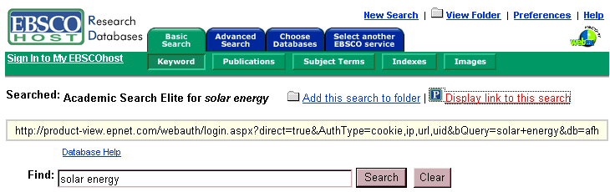

Print/E-mail/Save Options
For information about printing, e-mailing, or saving from Academic Search, please download the EBSCOhost Print/E-mail/Save User Guide.

Browsing Cited References
When a Basic or Advanced Keyword Search is performed, any available Cited References or Times Cited in this Database links are presented with your search results.
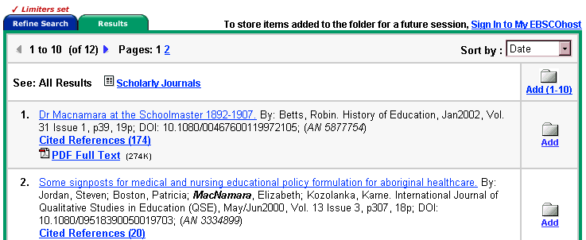
- Cited References are notes in a publication referring you to another source that the author used when writing the article. If you click the Cited References link for an article, the Cited References sub-tab presents a list of records cited in your original article.
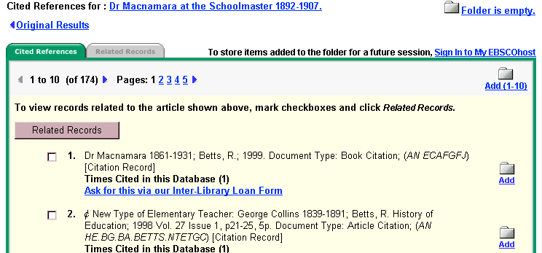
- Related Records – If you select one or more references and click the Related Records button, the Related Records sub-tab presents a list of records related to your original article. These records are sorted by relevance, based on the greatest number of shared references.
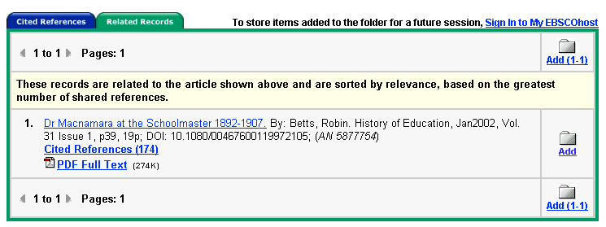
- Times Cited in this Database indicates the number of times the article being viewed was cited in other articles. If you click a Times Cited in this Database link, the Citing Articles sub-tab presents a list of records that cite your original article.
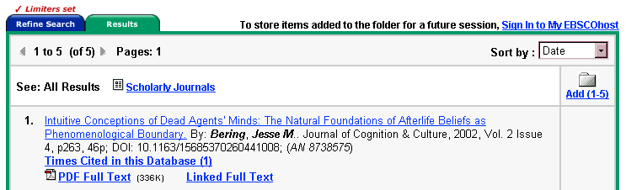
Cited References and Times Cited in this Database links are also displayed on the article detail page, and can be saved to the folder. However, linking to Cited References or Citing Articles lists is not available from the folder.

Detailed Citation Features
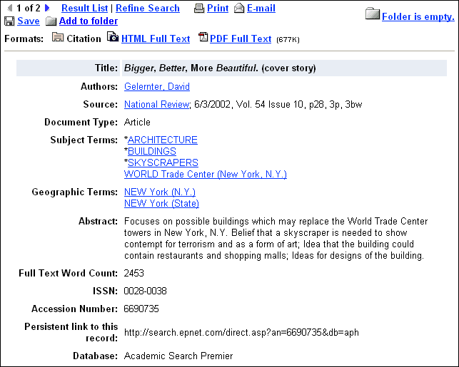
- Arrows – The double arrows next to the record number allow you to navigate to the previous or next result.
- Result List – This link returns you to the Result List.
- Refine Search – Click on this link to apply limiters and expanders to your search.
- Print/E-mail/Save – Click on these links when you want to Print, E-mail or Save the current result.
- Add to folder – This link adds the citation to your folder. For more information on folder functionality, please refer to the My EBSCOhost and Page Composer User Guide.
- Formats – Use these links to view other items available for this citation, e.g., PDF or Full Text.
The following items may change, depending on the item selected:
Note: Unless otherwise stated, clicking on a link in a citation will launch a new search for all articles with that term in the specified field.
- Title – This field contains the title of the article.
- Author(s) – This field contains the author(s) of the article as a hyperlink(s). Click on this link to retrieve all articles by the author that are represented in the database(s).
- Source – This field contains the article’s source publication, as well as the date and volume of the article. When you select the link to the source, you will receive all publisher information related to that title. When you select the volume information, a Result List is displayed with every article from that specific issue.
- Subject Terms – This field lists any subject headings to which the article is related.
- Author’s Keyword(s) – This field contains any author-supplied, searchable terms. If Keywords are in a language other than English, the corresponding language will be noted.
- Abstract – This field contains a synopsis of the article.
- Author Affiliation – This field displays any companies or organizations with which an author is affiliated.
- Full Text Word Count – This field displays the number of words contained in the full text of the article.
- DOI (Digital Object Identifier) – The DOI is a unique alphanumeric string assigned to a digital object by CrossRef®. In the CrossRef system, each DOI is associated with a set of basic metadata and a URL pointer to the full text, so that it uniquely identifies the content item and provides a persistent link to its Internet location.
- Accession Number (AN) – This field is the article’s unique identifier.
- Persistent link to this Article – This link to an article can be e-mailed or saved, and will allow you to retrieve an article by clicking on the link or entering it in the address field.
- Database – This field identifies from which database the article was retrieved.

HTML Full Text Features
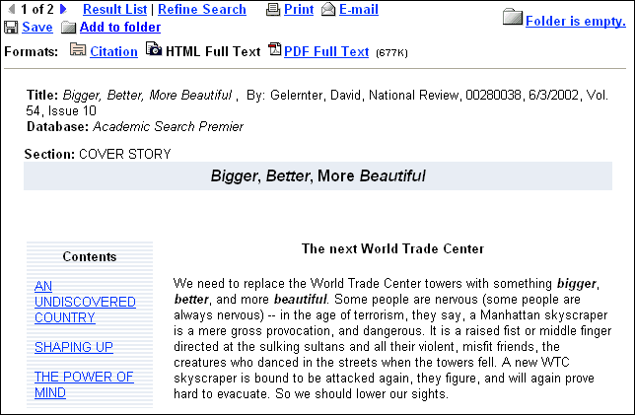
- Arrows – The double arrows next to the record number allow you to navigate to the previous or next result.
- Result List – This link returns you to the Result List.
- Refine Search – Click on this link to apply limiters and expanders to your search.
- Print/E-mail/Save – Click on these links when you want to Print, E-mail or Save the current result.
- Add to folder – This link adds the citation to your folder. For more information on folder functionality, please refer to the My EBSCOhost and Page Composer User Guide.
- Formats – Use these links to view full text formats available with this citation, e.g., PDF or Full Text.
- Contents – Some articles display a table of contents listing any paragraph headings that are available throughout the article. Clicking on one of these links will automatically bring you to that part of the article.
- Language Translation – If enabled, this feature allows you to translate a full text article into one of several languages: Spanish, German, Portuguese or French. (For more information about multilingual options, please refer to the EBSCOhost Multilingual User Guide.)

My EBSCOhost® and Page Composer
Please follow the link below to reference the My EBSCOhost and Page Composer User Guide:

Click here to view the My EBSCOhost and Page Composer User Guide.

For more information on EBSCOhost functionality, please visit our
Knowledge Base (Frequently Asked Questions) on the EBSCO Customer Support Site:
Click here to visit our Knowledge Base

Download the complete EBSCOhost User Guide:
Click here to view the EBSCOhost User Guide

